Qualities for an influential Senior Architect:
- Command over the product - Deep understanding of how the product works internally, its limits, trade-offs, and roadmap.
- Trusted advisor mindset - People seek your opinion before decisions, not after problems.
- Architectural thinking (system over solution):
- Always thinks in terms of end-to-end systems, not isolated fixes.
- Sees data ingestion, storage, compute, governance, cost, and operations as one system.
- Calm authority during ambiguity (when the Systems are failing, Stakeholders are pressuring)
- People feel safer when you’re in the room.
- Ownership mindset. – Gain the people trust
- Trade-off driven decision making
Never claims one solution is “best”. Explains why something is chosen and what is sacrificed.
Performance vs Cost
Flexibility vs Simplicity
Speed vs Governance

Data governance pillers - Include data lineage
Data architecture - simplify the definition
Virtualization Software - Azure (Hyper V)
Replace Azure Databricks Reference Architecture
Replace Azure Data Services, Top 3 Use cases/Features
Email having Roles/Access - Azure Databricks Compute Types — Expanded Comparison
Email - Azure Databricks Compute Types — Grouped by Cluster Family
rework in last topics
OOM Scenarios & solutions
Spark 5 performance issues and solutions
Databricks 5 performance issues and solutions
Python concepts
OOPS in Python
Design Patterns in Python
Spark 3.5, 4 features

Introduce yourself:
Hi, I’m Ramkumar. I started my career in 2003 as a developer at ABT Limited. After that, I spent 8 years working on SQL Server development, administration and performance tuning. During this time, I worked with companies like Verizon, Cognizant, and Bank of America.
In 2015, joined Capgemini as a Technical Architect and I worked on both on-prem big data and aws cloud technologies.
In 2017, I joined Credit Suisse bank, which is recently acquired by UBS bank. Since then, I’ve been playing various roles such as Big Data and Cloud Architect, ARB member, Product Owner of an application. I have been driving few department-level cost optimization initiatives as-well.
My core focus areas are to make use of the full potentials of Databricks and Delta Lake and started exploring MLOps capabilities as-well.

Azure Well Architected Framework:
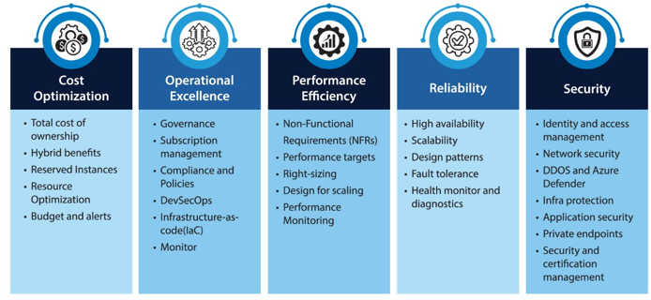
Databricks Well Architected Framework
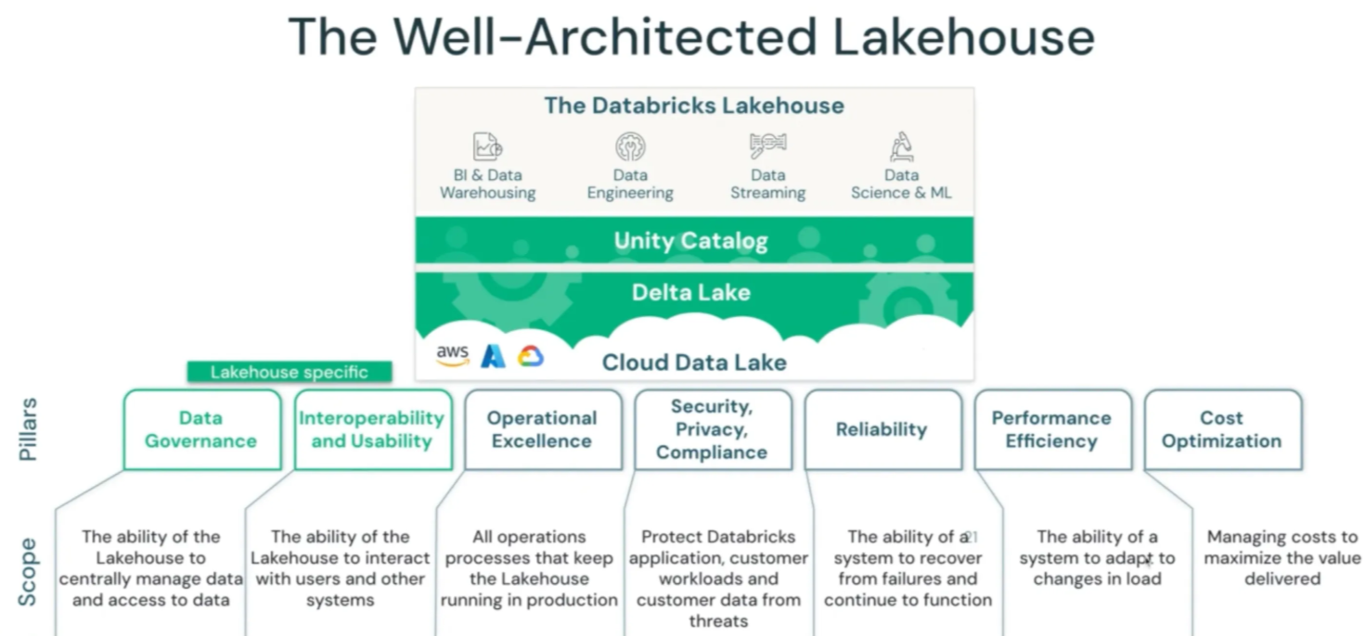

Terms for Architects:
Data Governance, Cost optimization, Security, Reliability, Performance, Availability/Fault tolerance, Scalability, Risk/Compliance, DR
Responsibilities: Ensure that architectural decisions within an organization align with its strategic goals, standards, and best practices.
Data governance pillars: Data ownership, Data quality, Data security & compliance, metadata management, data lifecycle management.
Data architecture is a discipline that define the structure, processes, governance, standards and best practices for collecting, storing, transforming, and using data to support business needs

General Concepts
Concepts:
Issue in On-premise: CAPEX & OPEX costs. Cost and delay in procuring server, cost for NW/System admins. Overhead for HW, OS, Libraries, license, maintenance, upgrade, security
Virtualization: Allows to run multiple OS on a singly host server
Virtualization software’s: VMWare workstation/vSphere, KVM (AWS), XEN (AWS), VirtualBox
Cloud computing - Providing Infra/platform/software as services over the Internet.
Cloud Benefits: No CAPEX, Time to market, pay as-you-go, Agility, Auto scaling, Highly available, Fault tolerance Wide range of services to meet all our needs
IAAS: Control Host, OS, Runtime, Application, Data. We are responsible for license, maintenance, upgrade, security
PAAS: Control over Application, data. No need to worry about HW, OS, Libraries related license, maintenance, upgrade, security
SAAS: Control over data. No need to worry about HW, OS SW license, maintenance, upgrade, security
- Cloud providers have limits on Compute, storage.
- Elasticity - add, remove, modify compute capacity depends on the load.
- Vertical Scalability (Add more capacity to existing server. downtime is required) vs Horizontal Scalability (Add more servers in the cluster for better performance)
- Cloud service providers supports Auto scalling based on metrics (ex: cpu load) or schedule.
Ports: HTTP 80, HTTPS 443, FTP 21, SSH 22 (Putty/Mobaxterm), IMAP 143, DNS 54, SQL 3306
Benefits of distributed system: Scalability, Fault tolerance, parallism and high availability

Terms for Architects: Trade offs (ex: Availability vs. Cost)
Availability, Scalability, Data Governance, Cost optimization, Security, Reliability, Performance, Fault tolerance, Risk/Compliance, DR
Responsibilities: Ensure that architectural decisions within an organization align with its strategic goals, standards, and best practices.
Data governance pillars: Data ownership, Data quality, Data security & compliance, metadata management, data lifecycle management.
Data architecture is a discipline that define the structure, processes, governance, standards and best practices for collecting, storing, transforming, and using data to support business needs
Multiprogramming vs Multitasking vs Multithreading:
Multitasking: CPU time is divided into small time slices and shared among all runnable tasks.
T1 → T2 → T3 → T1 → T2 → T3 → ... (each gets ~10 ms)
✔ Preemptive
✔ Time-sliced
✔ Fair sharing
Multiprogramming: One program runs continuously until it blocks (I/O, wait), then CPU is given to another program.
P1 runs ────────────── waits for disk
P2 runs ───────── waits
✔ Non-preemptive
✔ No forced time slicing
✔ CPU switches only on wait
✔ Throughput-focused

Multithreading – A thread is the smallest sequence of programmed instructions a core handles.
Executing several tasks simultaneously where each task is a seperate independent part of the same program, is called Thread based multi tasking, and each independent part is called a Thread.
In CPython, even on a 16-core machine, only one core executes Python bytecode at a time because of the Global Interpreter Lock (GIL).
Note: One CPU core can handle hundreds of threads, but only ONE thread executes at any instant
The GIL is a mutex that allows only ONE thread to execute Python bytecode at any given time within a single Python process. GIL Protects Python’s memory management
Multiple threads updating reference counts simultaneously would cause:
- Race conditions
- Memory corruption
- Crashes

When Multithreading IS Useful (Very Important)
- File reads
- Network calls
- Database queries
- API calls

Machine
├── CPU Core
├── Process (Program)
│ ├── Thread 1
│ ├── Thread 2
│ └── Thread 3

Databricks Tips:
Billing Tip: Billing for databricks DBUs starts when Spark Context becomes available. Billing for the cloud provider starts when the request for compute is received and the VMs are starting up.

Data Fundamental Concepts

Data & Information
Data is a collection of facts, figures, or information in a raw or unorganized form that can be processed, analyzed, or interpreted to produce meaningful insights.
For instance, the number "98.6" is just data, but when you know it represents body temperature in Fahrenheit, it becomes useful information. Data can be in int, string, date, image, log, video
Types of Data
Type | Meaning | Example
Structured | Organized in rows & columns | Excel, SQL tables
Semi-structured | Tags/format but no fixed schema | JSON, XML, logs
Unstructured | No predefined format | Videos, emails

Data Type | One-Liner Description | Example
Master Data | Core business information about key entities that provides context for transactions. | A customer's name, address, and contact details.
Reference Data | Static or slowly changing data used to categorize and classify other data. | Country codes (e.g., "US", "GB") or currency codes (e.g., "USD").
Log Data | Time-stamped, automatically generated records of events or activities within a system. | A server's access log detailing user IP addresses, request times, and accessed files.
Metadata | Data that describes other data, providing context, meaning, and usability. | The file size, author, creation date, and resolution of an image file.
Transaction data | Daily business operations | Orders, Payments, Clicks, Bookings

Database: Is a data repository for storing real-time operational data. Optimized for concurrent read/write operations. Used for OLTP workloads. Data is in normalized form. Follow ACID properties. Follow schema-on-write data models. Schema is required for data ingestion, reading and processing.
Data Warehouse: Is a centralized data repository for storing historical, structured data.
Used for OLAP and analytical workloads. Data is in denormalized form. Optimized for read-heavy queries and reporting. Follows schema-on-write data models. O
Data Lake: Is a scalable centralized data repository for raw structured, semi-structured, and unstructured data. Used for analytics, machine learning, and batch processing.
Follows schema-on-read approach. Does not enforce ACID by default.

Delta Lake: An open-source storage layer that adds data warehouse reliability to data lakes via ACID transactions, scalable metadata, and unified streaming/batch processing. It enables schema enforcement and "time travel" (versioning) on top of raw cloud storage, bridging the gap between traditional databases and simple data lakes.
Problems with Data Warehouse:
- Increased data volume
- Longer time to ingest new data
- Proprietary file format
- Scalability issues
- Higher storage cost
- Limited support for Data Science/ML/AI Use case
Problems with Data Lakes:
- Lack of ACID support
- Partial data loads (in case of issues)
- Inconsistent reads
- Power BI & Reporting performance
- Data corrections are not easy (Partitions, parquet formats are immutable)
- No rollback capability
- Lack of GDPR (General data protection regulation). Probability of data deletion
- Governance. No data versioning
Delta lake features:
- Supports all type of data (Structured, semi structured)
- Cheap cloud object storage
- Use open file format
- Support for all work loads (OLAP, Data Science, ML, AI etc)
- Direct BI integration
- ACID Support & Version history
- Improved performance
Data Lakehouse:
A Databricks Lakehouse is a unified data platform that merges the best of data lakes (flexibility, scale, low cost) and data warehouses (reliability, ACID transactions, governance) into a single system
- Lakehouse in Databricks unifies a data lake’s scalability with a data warehouse’s reliability and performance.
- Built on Delta Lake, which adds ACID transactions, schema enforcement, time travel, and reliability to files in cloud storage.
- Uses Unity Catalog for centralized governance: fine-grained access control, lineage, auditing, and consistent permissions across workspaces.
- Supports batch + streaming workloads on the same data with one copy.
- Enables collaboration across all users and data — data engineers, analysts, scientists, and ML teams work on the same platform.
- Runs BI/SQL, advanced analytics, and ML directly on open data formats (like Parquet/Delta).
- Reduces duplication and ETL complexity by eliminating separate lake + warehouse systems.
- Scales elastically and cost-efficiently by separating compute from storage while staying open and interoperable.
Medallion Architecture:
Medallion Architecture in Databricks shows how data becomes cleaner, more structured, and more valuable from Bronze to Silver to Gold (layered data refinement approach).
Medallion architecture is a data design pattern organizing data into quality layers: Bronze (raw ingestion), Silver (cleaned/filtered), and Gold (business-ready aggregates). This framework simplifies pipelines, ensures data reliability, and provides a clear path from messy source data to high-quality, actionable business insights.
Bronze – Raw data ingested from OLTP systems and other sources with minimal transformation, stored historically for audit, replay, CDC recovery, and troubleshooting;
Silver – Standardized. Filtered. Cleansed. Enriched with structure enforced. optimized for OLAP queries, data science exploration, and ML/AI feature engineering.
Gold – Business-ready, aggregated data optimized for dashboards, reports, and decision-making by business users.

What is RDBMS:
A Relational Database (RDBMS) stores data in tables (rows & columns) and follows a predefined schema.
Data is related using keys like Primary Key and Foreign Key.
Examples: MySQL, PostgreSQL, Oracle, SQL Server, SQLite
✔ Key Features:
- Structured tables (schema-based)
- Uses SQL for queries
- Supports JOINs across tables
- Strong data consistency
- Supports Normalization (reduces duplicate data)

ACID ensures reliable and consistent transactions in a database. It guarantees that data will never become corrupted, even if a failure happens during a transaction.
Property | Full Form | Meaning (Simple Words)
A | Atomicity | All or nothing — a transaction fully happens or not at all
C | Consistency | Data must follow rules and remain valid after transaction
I | Isolation | Parallel transactions do not affect each other
D | Durability | Once saved, data will not be lost (even if system crashes)

What is NoSQL Database?
NoSQL stands for “Not Only SQL” — it refers to a group of modern databases designed to handle large, fast-changing, or unstructured data that traditional relational databases struggle with.
NoSQL databases store data in flexible formats (JSON, key-value, documents, graphs) instead of fixed tables and schemas.
Why NoSQL? (Reasons to Use It)
Traditional relational databases face problems when:
✔ Data grows very fast
✔ Schema changes frequently
✔ Millions of requests per second
✔ Distributed systems / cloud environments

CAP Theorem – Used in Distributed / NoSQL Databases
In distributed systems, you can only guarantee 2 out of 3 of the following:
Property | Meaning
C – Consistency | Consistency ensures that all nodes in a distributed system have the latest and correct data before responding to users.
A – Availability | Availability ensures that the system always responds to every request, even if some nodes are slow, busy, or not returning the latest data.
P – Partition Tolerance | Partition tolerance ensures that the system continues to operate even when communication between nodes fails due to network issues or connection loss.
⚠️ In distributed systems, Partition Tolerance (P) is mandatory,
During a partition (node communication issues) you only have two choices:
- Stay available (serve requests, risk temporary inconsistencies), or
- Stay consistent (block/deny requests until the partition heals).

so databases choose between CP or AP:
Model | Focus | Example DB
CP | Consistent + Partition tolerant | MongoDB, HBase
AP | Available + Partition tolerant | Cassandra, DynamoDB
CA | Theoretically possible but not practical in distributed systems

Types of NoSQL Databases
Type | Example | Best Use Case
Document DB | MongoDB, CouchDB | JSON data, dynamic schema
Key-Value Store | Redis, DynamoDB | Caching, sessions, high-speed reads
Column Store | Cassandra, HBase | Big data, analytics
Graph DB | Neo4j, Amazon Neptune | Social networks, recommendations

Normalization in RDBMS
Normalization is the process of organizing the data in a relational database to minimize redundancy and dependency by dividing large tables into smaller ones and linking them using relationships.
Normal Forms
- First Normal Form (1NF): Eliminate repeating groups and ensure that each column contains only atomic values (no arrays or lists).

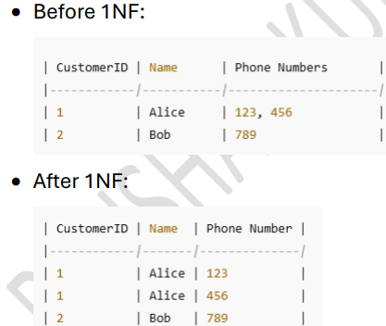

- Second Normal Form (2NF): Eliminate partial dependency, which means each non-prime attribute must depend on the whole of the primary key
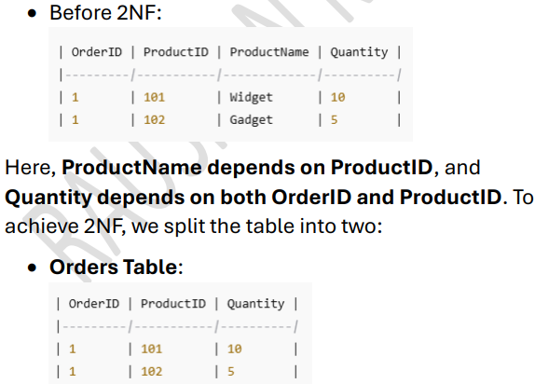

- Third Normal Form (3NF): Eliminate transitive dependency, meaning non-key attributes must not depend on other non-key attributes
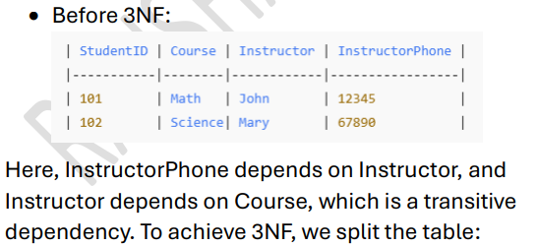
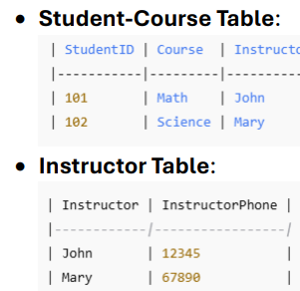

Data Modelling
Definition: Data Modeling is the process of creating a visual representation of data and its relationships to facilitate database design and ensure data integrity, performance, and usability. It helps structure data logically and physically for storage and analysis.

- Conceptual Data Model:
- High-level, abstract model focused on business requirements.
- Defines entities, relationships, and attributes without technical details.
- Example: Entities like Customer, Order, Product.
- Logical Data Model:
- Intermediate model that defines the structure of the data, including entity relationships, attributes, and data types, without focusing on the DBMS.
- Example: Customer has attributes like CustomerID (Primary Key), Name, Address.
- Physical Data Model:
- Implementation-focused, includes DBMS-specific details like table structures, indexes, data types, and constraints.
- Example: MySQL table creation with fields CustomerID INT AUTO_INCREMENT PRIMARY KEY.
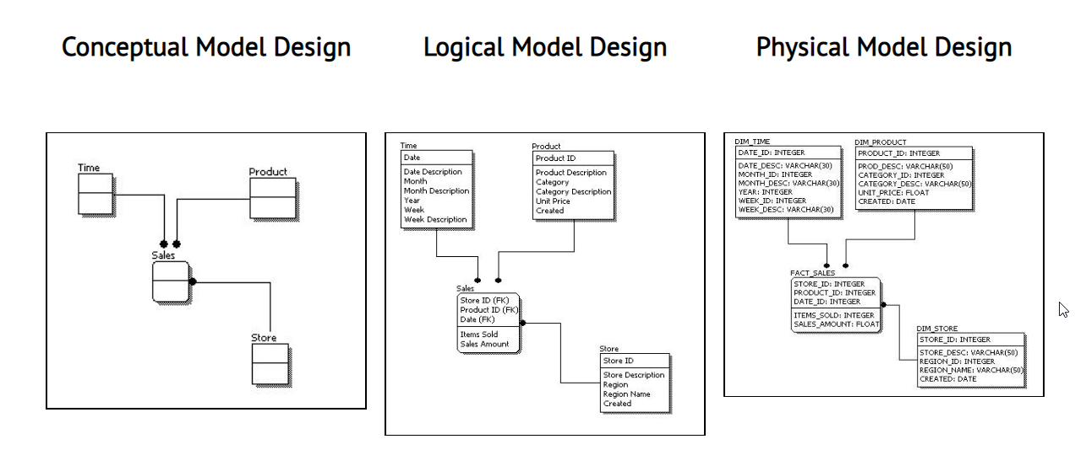

ER Model (for OLTP/RDBMS)
The ER model (Entity–Relationship model) is a data modeling technique used to design the structure of a database by identifying entities, their attributes, and relationships between them.
It is mainly used in OLTP systems and relational databases during the database design phase.

ER Diagram (conceptual data model):
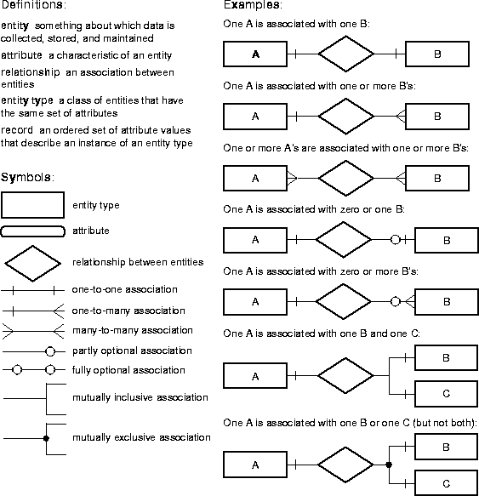

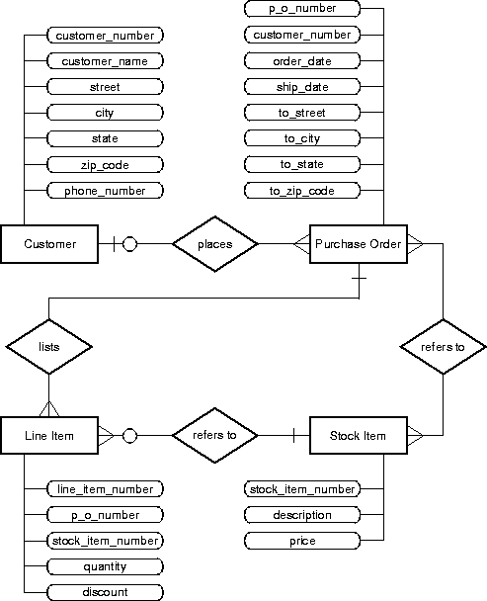
Reference: https://docs.oracle.com/cd/F49540_01/DOC/java.815/a64686/05_dev1.htm

Data Warehousing
A data warehouse is a centralized repository that combines data from various sources to support business intelligence (BI) and analytical activities.
- Denormalized. OLAP, Optimized for read, Historical data
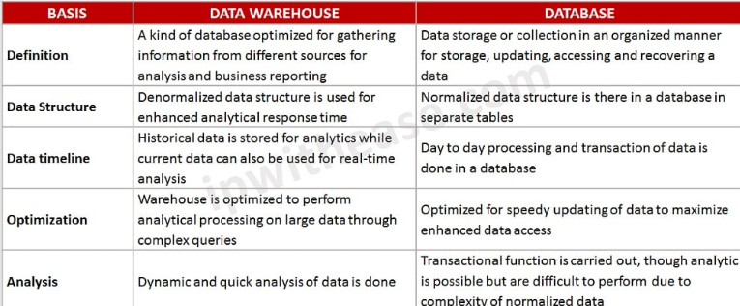

Kimball’s Dimensional Modeling Approach (for OLAP)
Kimball’s dimensional modeling is a widely used approach for data modeling in data warehousing and business intelligence (BI) applications.
In Kimball’s dimensional modeling approach, data is organized into two main types of tables: fact tables and dimension tables. Fact tables store the quantitative measures or metrics of interest, while dimension tables provide descriptive attributes or context for these measures. The relationships between fact tables and dimension tables are established through keys.
Star Schema
The central component of the star schema is the fact table, which holds the quantitative measures or metrics that are the focus of analysis. Surrounding the fact table are dimension tables
Snowflake Schema
The snowflake data modeling technique is an extension of the star schema. It aims to further normalize dimension tables to eliminate redundancy and improve data integrity.
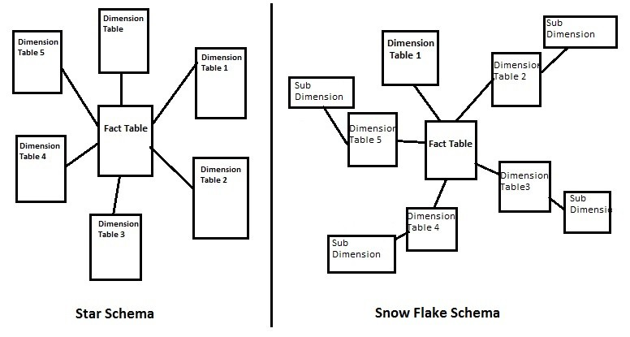
Fact tables:
Fact Table: Facts are numeric measures that represent business metrics.
- Central table that contains measurable, numeric data (facts).
- Includes foreign keys referencing dimension tables.
- Example: Sales_Fact table with fields SaleID, DateID, ProductID, CustomerID, and Revenue.

Types of Facts -
- Additive Facts:
  - Can be summed across all dimensions.
  - Example: Sales_Amount can be totalled by date, region, or product.
- Semi-Additive Facts:
  - Can be summed across some dimensions but not others.
  - Example: Account_Balance can be totalled by region but not over time.
- Non-Additive Facts:
  - Cannot be summed across any dimension.
  - Example: Ratios or percentages like Profit_Margin.
Types of fact tables:
- Transactional Fact Tables - Transactional fact tables are designed to capture individual business events or transactions
- Periodic Snapshot Fact Tables - A periodic snapshot fact table captures a summary of data at a fixed interval, such as daily, weekly, or monthly.
- Accumulating Snapshot Fact Tables - An accumulating snapshot fact table tracks the progress of a transaction/event
- Factless fact table - is a link table that contains only foreign keys to dimensions, but no numeric facts.

Dimension Tables: Dimensions provide the descriptive context for facts, enabling users to analyze and filter data from various perspectives.
- Surround the fact table and store descriptive, textual information about the facts.
- Example: Product_Dimension with fields ProductID, ProductName, Category.
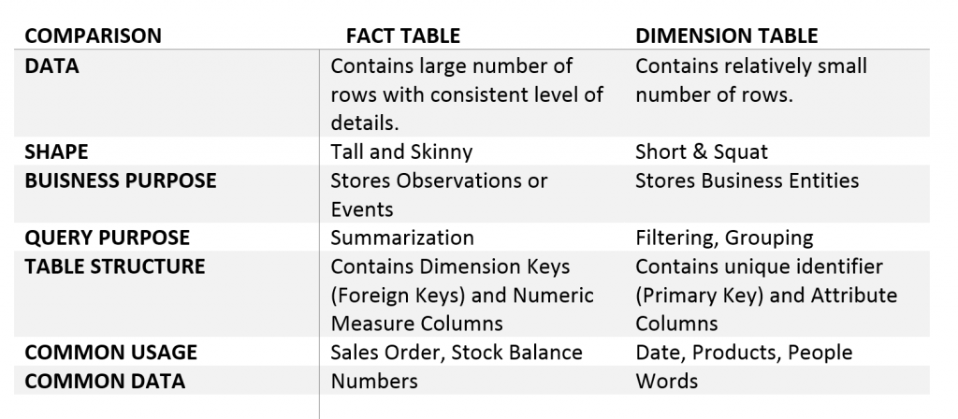
Examples of Dimensions:
- Time Dimension:
  - Attributes: Date, Week, Month, Year.
- Product Dimension:
  - Attributes: ProductName, Category, Price.
- Customer Dimension:
  - Attributes: CustomerName, Region, Age.
Types of Dimensions:
- Conformed Dimensions:
  - Shared across multiple fact tables or data marts.
  - Example: Time_Dimension used in both Sales_Fact and Inventory_Fact.
- Junk Dimensions:
  - Combines unrelated attributes into a single dimension to reduce clutter.
  - Example: Flag_Dimension for binary indicators like NewCustomer, PromotionalSale.
- Degenerate Dimensions:
  - Dimension data stored in the fact table itself.
  - Example: OrderID in a sales fact table.
- Role-Playing Dimensions:
  - A single dimension table used in different contexts.
  - Example: Time_Dimension used as Order_Date and Ship_Date.
- Slowly Changing Dimensions (SCDs)
Slowly Changing Dimensions (SCDs) are a methodology for handling changes in dimension data over time in a data warehouse while preserving the history of changes where required.

Types of SCDs
SCD Type 0 (Fixed Dimensions) - The dimension data is static and does not change over time.
SCD Type 1 (Overwrite) - When a change occurs, the old data is overwritten with the new data, and no history is maintained.
SCD Type 2 (Versioning) - Maintains full history by creating a new record for each change in dimension data.
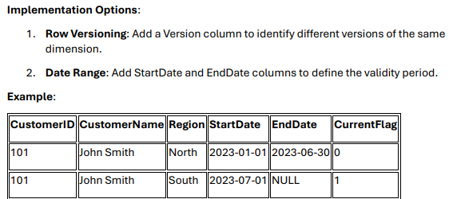
SCD Type 3 (Tracking Limited History) - Maintains limited history by adding columns to store previous values alongside the current value.
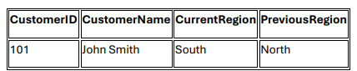
SCD Type 4 (History Table) - Maintains history in a separate table, while the main dimension table holds only the current data
SCD Type 6 (Hybrid SCD - 1+2+3) - Combines elements of SCD Types 1, 2, and 3 to track both historical and current data while maintaining versioning.

Database/Data Lake/Delta Lake/ Parquet files Definitions

Database:
A database is used to store and manage structured data for daily business operations. It follows ACID properties (Atomicity, Consistency, Isolation, Durability) to ensure reliable transactions. Databases are designed for OLTP (Online Transaction Processing) — handling frequent reads and writes, like banking transactions or e-commerce orders.
Data Warehouse:
A data warehouse stores large volumes of historical and structured data from multiple sources. Data is stored in denormalized format for reporting and OLAP analytics (Online analytic processing).
Data Mart:
A data mart is a smaller, focused subset of a data warehouse created for a specific business domain, like sales, marketing, or HR. It supports OLAP queries and helps teams quickly access relevant insights without scanning all warehouse data. Example: a finance mart for monthly revenue reporting.
Parquet Files:
Parquet is structured, columnar storage format. Parquet files are immutable because they’re columnar, compressed, and tightly encoded, making in-place edits impossible. Any change rewrites affected files or partitions and replaces them. Overwrites write new files, appends add more files. and table formats like Delta/Iceberg simply manage these rewrites with ACID guarantees - still no true in-place edits.
Data Lake:
A data lake stores raw data in any format — structured (Parquet), semi-structured (JSON, logs), or unstructured (videos, images). It’s mainly used for big data analytics, AI, and machine learning. Unlike a warehouse, it doesn’t enforce a strict schema upfront. Example: storing sensor data or website clickstreams for later analysis.
Traditional data lakes often turned into “data swamps,” where files were inconsistent and updates were difficult. Delta Lake solves this with ACID transactions, schema enforcement, and time travel
Data Mesh
In a Data Mesh, data ownership and management are decentralized, but data governance and standards remain centralized (federated). data teams will follow the common governance, metadata, and access standards to ensure consistency. It suits large enterprises where centralized data platforms struggle to scale efficiently.

Delta Lake
Delta Lake is a high-performance storage layer that adds reliability, quality, and governance to cloud data lakes. It allows you to execute ACID transactions, enforce schema integrity, and query historical versions of data, which ensures consistency and trustworthiness. Delta is used to enable both streaming and batch workloads to run on the same tables, reducing pipeline complexity. A Delta table consists of Parquet files enhanced by a transaction log that captures every operation. Delta also has advanced features such as schema evolution, time travel, and scalable metadata handling. It supports operations like upserts, deletes, and merges that are essential for maintaining data warehouses in the cloud. It also provides performance optimization features such as Z-order clustering, data skipping, and optimized compaction. For instance, an IoT system can ingest billions of sensor events in real time while compliance teams run monthly reports on the same data. Delta acts as the transactional backbone of the Lakehouse. Most importantly, it helps you to build pipelines that are both reliable and fast, even under massive workloads.

Delta lake concurrency control:
Optimistic Concurrency Control (OCC)
Optimistic Concurrency Control is a method for handling concurrent transactions by assuming that conflicts are rare. Instead of locking resources to prevent conflicts, OCC allows transactions to proceed independently and checks for conflicts only at the time of commit. If a conflict is detected, the transaction is aborted and must be retried.
Key Principles of OCC:
- No Locking: Transactions do not lock resources, allowing for high concurrency.
- Conflict Detection: Conflicts are detected at commit time by comparing the transaction's changes with the current state of the data.
- Retry Mechanism: If a conflict is detected, the transaction is aborted and must be retried.
How Delta Lake Implements OCC:
Isolation Levels in Delta Lake
Delta Lake provides serializable isolation, the highest level of isolation in database systems. This means that the result of executing multiple concurrent transactions is the same as if they were executed one after the other in some serial order.
How Isolation is Achieved:
- Read Isolation: Readers always see a consistent snapshot of the data as of the start of their transaction. This is achieved by reading the transaction log up to the version number at which the transaction started.
- Write Isolation: Writers are isolated from each other by checking for conflicts at commit time. If two transactions attempt to modify the same data, one will succeed, and the other will fail and need to retry.
Types of Conflicts in Delta Lake:
a. Write-Write Conflicts:
- Scenario: Two transactions attempt to modify the same file or partition.
- Example:
- Transaction A starts and reads version 1 of the table.
- Transaction B starts and reads version 1 of the table.
- Transaction A modifies file X and commits, creating version 2.
- Transaction B attempts to modify file X but detects that the table has been updated to version 2. Transaction B is aborted.
b. Append-Only Conflicts:
- Scenario: A transaction attempts to append data to a table while another transaction deletes or modifies the same data.
- Example:
- Transaction A starts and reads version 1 of the table.
- Transaction B deletes some rows and commits, creating version 2.
- Transaction A attempts to append data but detects that the table has been updated to version 2. Transaction A is aborted.
c. Schema Conflicts:
- Scenario: A transaction attempts to modify the schema of a table while another transaction is reading or writing data.
- Example:
- Transaction A starts and reads version 1 of the table.
- Transaction B modifies the schema and commits, creating version 2.
- Transaction A attempts to write data but detects that the schema has changed. Transaction A is aborted.

Lakehouse
A Lakehouse is a modern data architecture that combines the strengths of data lakes and data warehouses. Data lakes offer scalability, flexible storage of structured and unstructured data, and support for batch and streaming processing, while data warehouses provide structured storage with schema enforcement, high-performance querying and analytics, and robust data governance. The Lakehouse brings all these capabilities together, delivering a single platform that is scalable, flexible, governed, and optimized for analytics and AI workloads, providing a holistic solution for modern data needs. It allows you to store structured, semi-structured, and unstructured data in a single platform, which eliminates the complexity of managing separate systems. The Lakehouse is used to unify storage and analytics so that data duplication and costly ETL between lakes and warehouses are minimized. It consists of three primary layers: a low-cost storage layer, a transaction and governance layer, and a serving layer for BI and ML workloads. The Lakehouse also has capabilities such as ACID transactions, schema enforcement, and auditing that are traditionally associated with data warehouses. It supports diverse workloads, from interactive SQL analytics to advanced machine learning. It also provides the flexibility to scale cost-effectively on commodity storage. For instance, a retail company can run Power BI dashboards, streaming demand forecasts, and AI-driven recommendations directly on Lakehouse data. It acts as the single source of truth for enterprise-wide analytics. Most importantly, the Lakehouse helps you to achieve both agility and governance in your data strategy.
Data Pipelines and Medallion Architecture:
The relationship between Medallion Architecture and Data Pipelines is simple: Medallion is the strategy, and the Pipeline is the execution.

Medallion Architecture in Databricks
The Medallion Architecture is a layered design used to improve data quality step by step. It consists of three layers: Bronze, Silver, and Gold. The Bronze layer stores raw data directly from source systems, which may include duplicates or errors. The Silver layer provides cleaned, filtered, and standardized data that combines multiple sources and applies business rules. The Gold layer has curated datasets that are ready for dashboards, reports, and machine learning. This design supports incremental processing, so only new or updated data moves across layers, making pipelines faster and cheaper. For instance, as data flows from Bronze to Silver to Gold, its quality and usability improve at each stage. Delta Lake features like ACID transactions, schema enforcement, and time travel help you make the Medallion approach reliable, scalable, and trusted for enterprise use.
- Bronze layer:
It acts as a landing zone where data is ingested in its original, raw format without any transformations or quality checks. This layer serves as a historical archive, providing a complete record of all incoming data and allowing for future auditing and reprocessing. Data in this layer is often immutable and append-only.
- Silver Layer: Data from the bronze layer is cleansed, filtered, and enriched in this layer. The primary goal is to refine the data into a more structured and usable format. Tasks performed here include deduplication, handling missing values, standardizing data formats, and joining data from multiple sources to create a unified view. This layer is often used for self-service analytics and machine learning.
- Gold Layer (Analytics-Ready Data): This is the final layer where data is fully refined and aggregated for high-value business analytics and reporting. The data in this layer is highly structured, denormalized, and optimized for fast queries by business analysts, data scientists, and business intelligence (BI) tools.
You can think of Bronze as “what happened,” Silver as “what is valid,” and Gold as “what is useful.”
Difference between Data lake and Medallion architecture
A Data Lake focuses on the concept of organizing and storing data in different zones but doesn’t define the technology or method to implement those layered systems. In contrast, the Medallion Architecture provides a technical framework for both data storage and processing, using Databricks, Delta Lake, and Delta Live Tables (DLT) pipelines for data quality, lineage, and automation.

Apache Spark

Apache Spark
Apache Spark is a open-source, in-memory, distributed computing framework designed for big data processing.
Unified means it offers both batch and stream processing
In Databricks, a Spark application's workflow involves a driver that manages the overall execution and executors that perform the actual computation. The driver splits the application's work into smaller tasks and distributes them to executors, which process the data in parallel and return results back to the driver.
Spark Architecture:
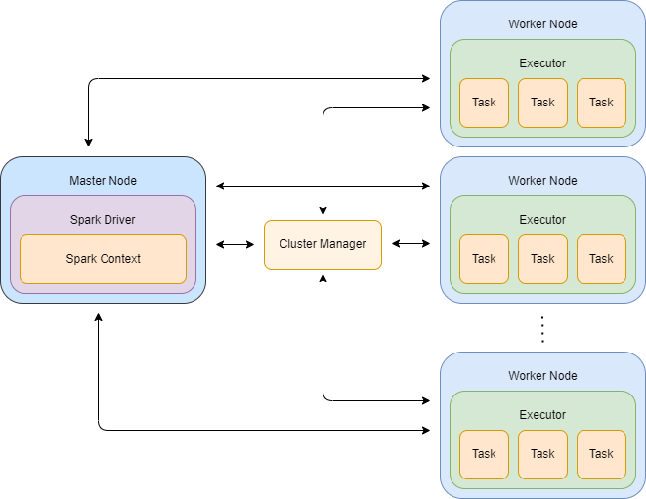
Spark components:
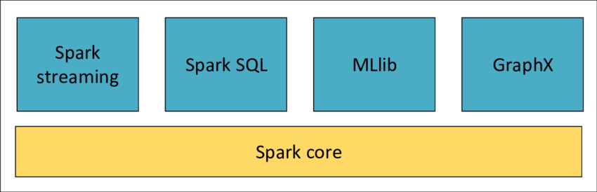

Note: If 100 users submit spark jobs in parallel, 100 spark sessions will be created. Each session has its own JVM (driver components). However, there will be only one Cluster manager and one set of executors which will be shared by 100 users
1. Spark Core
- Foundation of Spark responsible for execution, scheduling, and fault tolerance.
- Provides RDD (Resilient Distributed Dataset) as the low-level distributed data structure.
- DataFrames and Datasets are built on top of RDDs.
- DataFrames and immutable. You can’t overwrite but you can create new one
- All Spark modules internally depend on Spark Core and SparkContext.

🔹 2. Spark SQL
- Used to process structured/semi-structured data using SQL queries.
- Every SQL query is internally converted into a DataFrame, which then becomes RDDs for execution.
- Uses Catalyst Optimizer and Tungsten Engine to optimize query execution.
- Supports batch & streaming with integration to Structured Streaming.
🔹 3. Spark Structured Streaming (Modern API)
- Built on Spark SQL and DataFrame API — easier and more reliable than DStreams.
- Processes real-time data using DataFrames/Datasets, not RDDs directly.
- Supports exactly-once processing, watermarking, window aggregation.
- Ideal for IoT, fraud detection, real-time dashboards, and live analytics.
- Streaming now uses DataFrames internally — just like batch processing.
🔹 5. Spark MLlib (Machine Learning Library)
- Distributed ML library built on top of DataFrames and ML Pipelines.
- Uses RDDs in older versions, but now DataFrames are preferred for better performance.
- Supports classification, clustering, regression, feature engineering, evaluation.
- Easily integrates with MLflow and Delta Lake for production ML pipelines.

In Apache Spark, there are four core abstractions for working with distributed data:
- RDD (Resilient Distributed Dataset)
The RDD is the fundamental building block of Spark Core. It is an immutable, distributed collection of objects partitioned across the cluster. RDDs do not have schema’s. Each RDD keeps track of its lineage, which is a record of the sequence of transformations that created it. This lineage allows Spark to recompute lost partitions in case of failures, making RDDs fault-tolerant.
- DataFrame
A DataFrame is a higher-level abstraction built on top of RDDs, designed for working with structured and semi-structured data. It organizes data in table format (with rows and columns). DataFrames provide SQL-like operations, such as select, groupBy, and join, and are optimized internally using the Catalyst query optimizer.
- Spark SQL
Spark SQL is the module that allows querying structured data using standard SQL syntax. Behind the scenes, Spark SQL queries are converted into DataFrame operations, which are then optimized using the Catalyst engine.
- Dataset
Datasets are a typed extension of DataFrames available in Scala and Java. They combine the benefits of RDDs (type-safety and functional operations) with DataFrames (Catalyst optimization). In PySpark, Datasets are not available.

- Languages Supported: Java, Scala, Python, and R.
- Deployment Modes: Hadoop YARN, Apache Mesos, Kubernetes, Standalone cluster manager.

Spark Datasets, a type-safe structured API, are primarily designed for statically typed languages like Scala and Java. Python, being a dynamically typed language, doesn't have the same compile-time type checking capabilities, making it unsuitable for Datasets
Python is considered a dynamically typed language, meaning the type of a variable is determined during program execution
A SparkSession acts as a connection manager between the user and a Spark cluster. It's the entry point for working with Spark core functionalities , providing a unified interface for accessing various Spark functionalities, including DataFrame and Dataset APIs, as well as SQL queries.
This means you can load data, perform transformations, execute SQL queries, and interact with Spark's APIs all through this one object.
In Apache Spark, a shuffle is a process that redistributes data across a cluster. It's a critical but costly operation because it involves moving data over the network and writing to disk. Shuffling is a consequence of certain transformations that require data to be grouped or aggregated.
Data Partitions in Spark
Apache Spark automatically partitions RDDs and DataFrames, and each partition is executed as a separate task on an executor. This improves scalability, performance, and fault tolerance. A good partition strategy combined with columnar file formats like Parquet or Delta Lake further boosts performance by enabling predicate pushdown, efficient compression, and parallel I/O. However, too few partitions reduce parallelism, while too many partitions increase scheduling overhead and slow down execution
RDDs, ADLS and Files:
- IMPORTANT: RDDs keep instructions (lineage) about how to rebuild data. They don’t store the real data unless cached.
- Spark does not work on full files. It first splits data into logical partitions internally.
- Each partition becomes a task. Tasks are the smallest schedulable unit Spark can run in parallel.
- Parallelism is limited by total executor cores. Extra partitions must simply wait in the queue.
- Too many partitions beyond available cores add overhead. A directory with many tiny files creates many tiny partitions. The job slows because management cost is bigger than the actual work.
Every partition creates a task, and each task has cost:
- scheduling overhead
- task startup time
- extra shuffle files
- extra metadata
- more JVM objects
- more garbage collection

- A 1-TB splittable file becomes thousands of partitions, allowing Spark to spread work across executors efficiently.
- A 1-TB gzip file is not splittable. Spark is forced to run one large task — very slow and under-utilized.
- Use repartition only when data is badly skewed. Prefer coalesce or Delta OPTIMIZE to reduce file counts safely.
- Reading a folder means Spark loads all files, but still partitions based on internal split size, not the number of files.
- Narrow transformations keep data inside each partition, so they avoid network communication and run cheaply.
- Wide transformations require grouping or joining across keys, so Spark must shuffle data across nodes.
- A shuffle is expensive because Spark writes to disk, sends data over the network, and recreates partitions again.
- ADLS separates storage from compute, letting you scale clusters independently while data stays cheap and reliable.
- ADLS hierarchical namespace makes file renames and Delta commits fast, which directly improves pipeline stability.
- ADLS supports parallel reads and writes. Multiple executors can read different blocks of the same file at once.
- Delta on ADLS brings ACID transactions, schema control, streaming reliability, and safe concurrent writes.
- More partitions help until cores are fully utilized. Beyond that, overhead grows faster than performance.
- Shuffles, unnecessary repartitions, and uncontrolled small files usually become the biggest performance bottlenecks in production.
- Good design focuses on: right partition sizes, fewer shuffles, balanced keys, and compact Delta files.

Structured File formats:
Structured  File format | Mutability | Key properties
Parquet | Immutable (rewrite/append only) | Columnar, compressed, schema-enforced, fast analytics, predicate pushdown
ORC | Immutable (rewrite/append) | Columnar, very high compression, optimized for Hive, strong indexing & pruning
Avro | Append-friendly | Row-based, schema-first, great for streaming and schema evolution
CSV | Mutable (text editable) | Semi structured. Simple, human-readable, tabular, but weak typing and no schema enforcement
Delta Lake (on Parquet) | Managed rewrites (ACID) | ACID transactions, time-travel, schema enforcement, scalable upserts/merges
How tasks are created:
Spark task creation – simple English logic
- Spark first looks at the query filters
  - Example: date = '2026-01-01'
  - It decides which partition folders are needed
  - It ignores all other folders
(No data is read yet)
- Spark collects a list of files
  - From the selected partition folders
  - For each file, Spark only checks:
    - File path
    - File size (from storage metadata)
  - Spark does not look inside the Parquet file yet
- Spark adjusts file size internally
  - For every file, Spark adds a small “open cost”
  - This is to avoid creating too many tiny tasks
- Spark starts grouping files -> per task
  - It creates an empty group (called an input partition)
  - It keeps adding files to the group
  - It stops adding when the total size reaches about 128 MB (spark.sql.files.maxPartitionBytes)
  - That group is now finalized
- Spark repeats the grouping
  - It creates the next group
  - Adds more files until the size limit is reached
  - Continues until all files are grouped
- Only now does execution start
  - Each task runs on one executor core
  - A task:
    - Opens its files one by one
    - Reads Parquet metadata
    - Reads row groups one at a time
    - Processes rows in small batches
  - The task never reads everything into memory at once

Transformations and Actions:
In Spark, operations on data are classified into transformations and actions, which define how Spark executes computations.
Transformations are lazy operations that create a new DataFrame or RDD from an existing one without executing any computation immediately. They build a logical plan that Spark records for later execution.
Examples include map, filter, select, withColumn, groupBy, and join. Because transformations are lazy, multiple transformations can be pipelined together, and Spark only computes them when an action is triggered.
- Narrow transformations process data within a single partition without requiring data to be shuffled or redistributed across partitions. Ex: SELECT, WITHCOLUMN, FILTER, UNION, DISTINCT, ORDER BY,
- Wide transformations require data to be shuffled or redistributed across partitions.
Example: Sort() or OrderBy() both are same. GroupBy(), Join(), Repartition(), distinct(), dropduplicates(),
Note: Wide transformations leads to shuffles and stages in job.
Actions are operations that trigger execution of the transformations. They produce a result to the driver or write data to external storage. When an action is called, Spark optimizes the entire lineage of transformations using the Catalyst optimizer, generates the physical plan, and schedules tasks on executors. Examples of actions include collect, count, show, take, write, and saveAsTable.
Common Actions:
- count(): Gets the total number of rows in a DataFrame or RDD.
- collect(): Retrieves all rows of a DataFrame or RDD as a list.
- show(): Displays a preview of the first few rows of a DataFrame.
- save(): Writes the DataFrame to external storage (e.g., a file).
- take(n): Returns the first n rows of a DataFrame or RDD.
- first(): Returns the first row of a DataFrame or RDD.

Spark Processes (Driver, Cluster Manager)
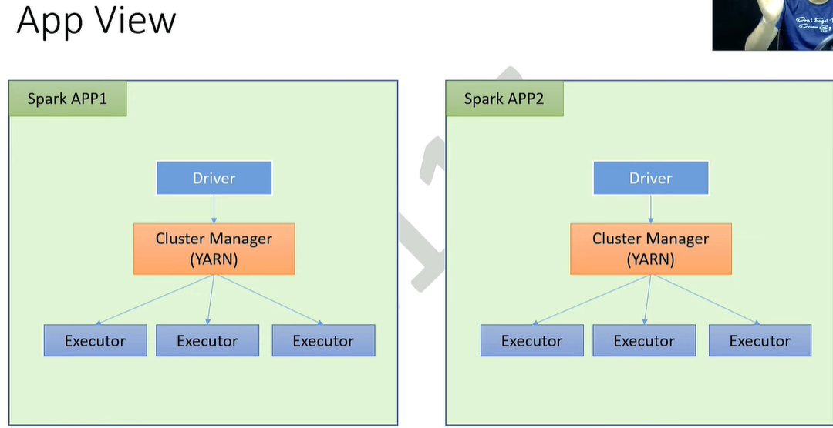
In Spark, Driver and Workers are Spark processes (JVM applications), not physical machines. These processes run on top of machines — the machine hosting the driver process is called the driver node, and the machines hosting worker processes (and their executors) are called worker nodes.
When a PySpark application starts, Spark brings up two tightly coupled processes on the Driver node: a Python process and a JVM Driver process.
In PySpark, the JVM process is indeed considered the driver of the application because it hosts the SparkContext and manages all orchestration logic
Q: in case of 100 user pyspark applications, 100 python and 100 jvm processes (driver) will be created for the lifetime of those applications?
Yes, for 100 independent PySpark applications, a total of 100 Python processes and 100 JVM driver processes will be created
Q: won't there be any common driver process for all app requests in driver machine?
No, there is no common driver process. Spark uses an isolated architecture where each application is a self-contained unit with its own driver and resources
Why this happens:
- One Driver per Application: By design, every Spark application must have exactly one driver process that manages its specific tasks, DAGs, and executor communication.
- Isolation: This isolation ensures that if one application's driver crashes or leaks memory, it does not affect the other 99 applications.
- Resource Management: Each driver is launched as a separate container or process (depending on the cluster manager like YARN or Kubernetes), allowing the system to track and limit its specific memory and CPU usage
Q: if there are 100 driver processes (jvm) how does those apps negotiate work node hardware compute capacity? which process co-ordinate, prioritize these
The Central Coordinator: The Cluster Manager
The Cluster Manager is an external service responsible for monitoring the total compute capacity of all worker nodes and deciding how to distribute those resources among competing applications. It acts as the "referee" that prevents 100 drivers from overwhelming the cluster's hardware.
Common Cluster Managers used in 2026 include:
- Hadoop YARN: Uses a ResourceManager to manage global cluster resources.
- Kubernetes (K8s): Uses the K8s Scheduler to place driver and executor pods based on node availability.
- Spark Standalone: A simple, built-in manager where a Master process tracks worker resources.
Resource sharing:
In both Fair and Capacity schedulers, an application can "borrow" the unused compute share of another. What happens next depends on whether Preemption is enabled:
Feature | Preemption Enabled | Preemption Disabled
Owner Impact | Gets resources quickly. | Experiences delays/starvation.
Borrower Impact | Tasks are killed and must restart. | Tasks finish normally.
Efficiency | High agility, potential wasted work. | High stability, potential idle wait

Spark application lifecycle:
When a PySpark application starts, Spark brings up two tightly coupled processes on the Driver node: a Python process and a JVM Driver process. These two communicate via Py4J, a socket-based bridge. The Python process is where the user’s code runs, but it doesn’t do the actual heavy computation. Instead, Python creates an expression tree that says “add 1 to column age,” and sends this request to the JVM Driver. Importantly, Spark uses lazy evaluation, which means these instructions are not executed immediately; instead, they accumulate as part of a logical plan. Execution only begins when an action is called (e.g., show(), collect(), or write()), at which point Python tells the JVM Driver, “Now it’s time to execute.”
Once the JVM Driver receives the instructions, it does all the heavy lifting through the Spark engine components. The Catalyst SQL engine first constructs an Unresolved Logical Plan (symbols without validation). Then the Analyzer checks the catalog/metastore and replaces symbols with actual schema references, producing a Resolved Logical Plan. The Optimizer applies rule-based improvements like predicate pushdown and constant folding, and if statistics are available, the Cost-Based Optimizer (CBO) generates multiple candidate physical plans, estimates their execution cost, and picks the cheapest. The Planner produces the Final Physical Plan, which the DAG Scheduler splits into stages (groups of tasks separated by shuffle boundaries), and the Task Scheduler breaks each stage into fine-grained tasks and requests executors from the cluster manager. Finally, the tasks are serialized and shipped to the Executors (JVM processes running on worker nodes). Executors run the tasks in parallel on data partitions and return partial results (or write data out) to the Driver. The JVM Driver then aggregates results and sends them back to the Python process, which prints or returns them to the user.
How task assignment really works
- The TaskScheduler does not dump the entire task list into executors in one go.
- Instead:
  - Driver (via DAGScheduler + TaskScheduler) creates the full list of tasks for a stage (one task = one partition).
  - These tasks go into a task queue on the driver.
  - Executors are launched by the cluster manager (YARN/K8s/Standalone/Databricks).
  - When an executor registers, it tells the driver: “I have free slots”.
  - The TaskScheduler assigns tasks from the queue to the free slots.
  - Once a task finishes, the executor reports back → “I’m free” → TaskScheduler gives it another task from the queue.
Now, regarding the multi-user question: each independent PySpark application has its own Python process and its own JVM Driver process. If 100 unique users submit scripts, the system will create roughly 100 Python processes + 100 JVM Driver processes, one pair per user. There is not a single global Spark engine inside the Driver that all users share; instead, each JVM Driver process is a full Spark engine instance with its own Catalyst optimizer, schedulers, and cluster resources. Executors are also allocated per application, so each user’s Spark job is isolated, and their JVM Driver acts as the command center for that job.

Driver JVM components:
├── SparkSession
│ └── SparkContext
│ ├── DAGScheduler (Break jobs in to stages)
│ ├── TaskScheduler (Decide which task to run in which core/executor)
│ ├── SchedulerBackend (Talks to the Cluster manager to request executors)
│ ├── BlockManagerMaster (Tracks where data blocks are stored)
│ ├── HeartbeatReceiver (Monitor executor health)
│ └── LiveListenerBus (Collect event logs)
├── SQL components (if using Spark SQL)
│ ├── Catalyst Parser (Convert SQL into logical plan)
│ ├── Catalyst Analyzer (Validate tables, columns and data types)
│ ├── Catalyst Optimizer (optimizer – remove unused columns, push filters..)
│ └── Physical Planner (Choose how to execute the queries.. which join is efficient…)
├── Spark UI (Jetty server)
└── User application code (your PySpark / Scala code)

Let us first set the foundation with some key definitions.
What is Apache Spark
Apache Spark is a open-source, in-memory, distributed computing framework designed for big data processing in parallel. It supports languages such as Pythan, Scala, Java, SQL and R.
Apache Spark is a unified analytical engine as it provides one single engine that can handle various types of big data workloads such as batch processing, streaming, machine learning, sql analytics and graph processing.
SQL Engine:
When a user runs commands in multiple cells in an Azure Databricks notebook with a series of transformations, Spark does not execute them immediately. This is because Spark follows lazy evaluation. Each transformation such as select, filter, or join is simply recorded as part of a logical plan inside the driver, but the actual computation is deferred. Only when an action such as .show(), .count(), or .write is called does Spark trigger the execution. Lazy evaluation allows Spark to look at the entire lineage of transformations before execution and apply global optimizations.
At this point, the SQL Engine begins its full lifecycle. The first step is to create an unresolved logical plan, which is a direct representation of the user’s code without knowing whether column names or table names actually exist. This plan is then transformed into a resolved logical plan, where Spark consults the catalog and metadata to verify references and resolve them to actual schema definitions. Once resolved, the plan goes through a series of optimizations.
The Catalyst Optimizer is the heart of Spark’s SQL Engine. Its job is to improve the query before execution. Catalyst performs three major functions. First, it applies Rule-Based Optimizations (RBO). These are standard rewrite rules like constant folding, predicate pushdown, null propagation, and projection pruning that simplify the plan and reduce unnecessary operations. Next, if table and column statistics are available, Catalyst performs Cost-Based Optimizations (CBO). Here, different strategies are evaluated based on estimated cost, and the most efficient execution plan is selected. For example, if one side of a join is very small, the optimizer may choose a broadcast join instead of a shuffle join. After these optimizations, the result is an optimized logical plan. This plan is then converted into a physical plan, which represents the actual execution strategy. Finally, the physical plan is transformed into an RDD lineage graph, which expresses the computation at Spark’s core RDD level. At this point, Tungsten comes into play with execution-level optimizations such as whole-stage code generation, vectorized processing, and memory management to make the execution as efficient as possible.
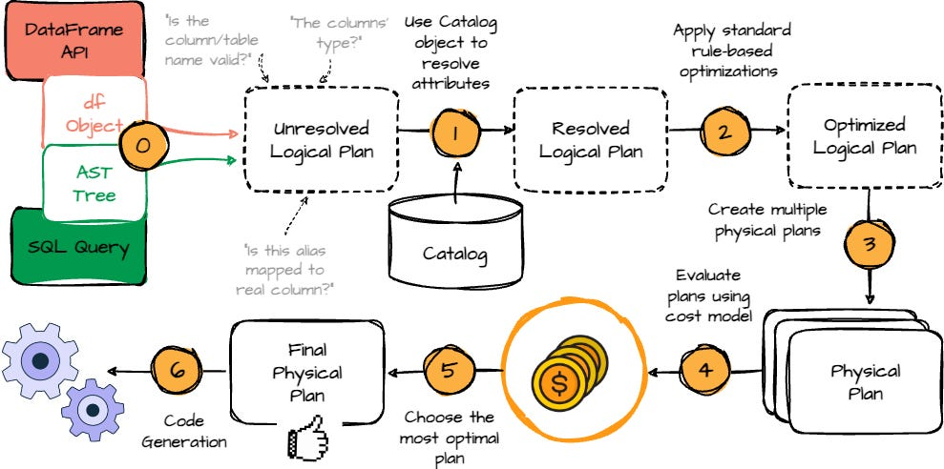
Will transformations create multiple copies of RDDs in memory:
In PySpark, each DataFrame transformation does not create a full in-memory copy. Transformations are lazy; Spark builds a lineage graph of RDDs, where each RDD stores the transformation function and references to parent RDDs, not the data itself. Actual computation occurs only when an action (e.g., show(), count()) is invoked. For memory efficiency, Spark executes tasks partition by partition and store intermediate results in memory or spilling to disk if needed. It Cache/persist an RDD for reuse.
Scheduler:
With the plan ready, the Scheduler takes over. The RDD lineage is submitted to the SparkContext, which is the entry point and the master coordinator of the Spark application. SparkContext passes the lineage to the DAGScheduler, which breaks the computation into stages at shuffle boundaries and builds a Directed Acyclic Graph of stages. Each stage is expressed as a set of tasks and submitted to the TaskScheduler. The TaskScheduler is responsible for assigning tasks to resources, but it does not manage resources directly. Instead, it works with the SchedulerBackend, which communicates with the Cluster Manager.
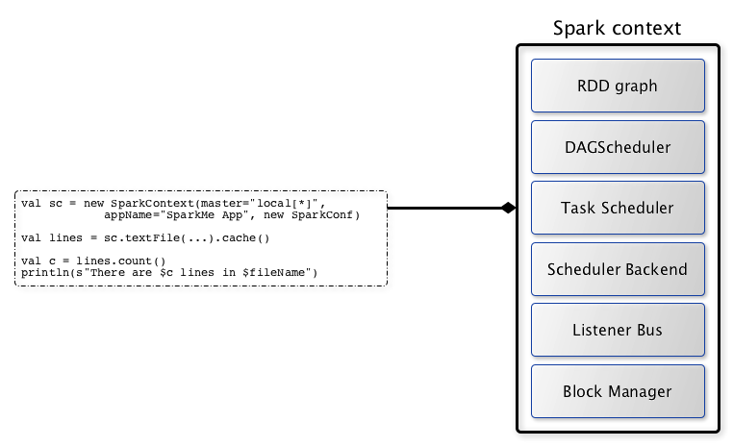

Cluster Manager:
The Cluster Manager is responsible for allocating resources such as executors, CPU cores, and memory. When multiple applications demand more resources than the cluster has, the cluster manager performs resource negotiation. In Databricks, autoscaling may add nodes to increase capacity. In other environments like YARN or Kubernetes, scheduling policies such as FIFO or Fair Scheduling are applied. This ensures resources are shared fairly or based on priority. The driver, through the SchedulerBackend, negotiates with the cluster manager to acquire executors. Once granted, tasks are shipped to executors.
Executors:
Executors are the worker processes running on the cluster nodes. They are responsible for fetching data from storage such as ADLS, Delta, or Parquet, executing the transformations defined in the physical plan, and either returning results to the driver or writing output back to storage. As tasks complete, results and status updates flow back from executors to the SchedulerBackend, then to the TaskScheduler, then to the DAGScheduler, and finally to the SparkContext, which delivers the outcome to the notebook cell.
In Spark, executors communicate with both the driver and the cluster managers.
Executor → Driver
Executors send detailed task-level information back to the driver, including:
- Task status (running, completed, failed)
- Task metrics (time taken, bytes read/written, CPU/memory usage)
- Shuffle and stage metrics (records read/written, spill size, shuffle fetch time)
- Accumulator updates (counters or sums for job-level metrics)
- Logs or exceptions in case of task failures
This allows the driver (via DAGScheduler and TaskScheduler) to monitor progress, handle retries, update stages, and eventually return results to the user.
Executor → Cluster Manager
Executors report heartbeat and resource health information to the cluster manager, including:
- Executor liveness (alive or dead)
- Resource usage (CPU, memory, disk)
- Node health and availability
The cluster manager uses this information to:
- Detect failed executors and restart them if needed
- Track cluster resource availability for scheduling new executors
- Make decisions for dynamic allocation when scaling the cluster up or down

Failure handling:
Failure handling is an important part of the lifecycle. If a task fails because of a transient error or data issue, the TaskScheduler retries it on another executor, and Spark recomputes the lost partition from lineage. If an executor itself fails due to node crash or out-of-memory errors, the cluster manager informs the driver, and Spark reschedules the unfinished tasks on other executors. Dynamic allocation may also provision new executors to replace failed ones. However, if the driver fails, the entire Spark application stops because the driver holds the SparkContext, the DAG, and all coordination logic. In client environments like Databricks notebooks, the job must be manually restarted. In cluster-managed deployments such as YARN or Kubernetes, the driver may be restarted automatically, but still the application must reinitialize.

In Summary:
Spark Core is the foundational engine of Apache Spark. It provides essential services such as memory management, fault recovery, task scheduling, job distribution, and monitoring
Spark core engine performs the following tasks in Driver, Executors and Cluster Manager.
1. In Spark Driver
- DAG Scheduler (creates DAG of stages)
- Task Scheduler (launches tasks on executors)
- Cluster Manager Interface (talks to cluster manager for resources)
- RDD lineage & job metadata management
2. In Cluster Manager (Standalone, YARN, K8s, etc.)
- Resource allocation (decides which worker gets how many executors)
- Heartbeats / health checks
- No Spark Core logic here → cluster manager is outside Spark Core, but Spark Core connects to it.
3. In Worker Node (Executor Process)
- Task Execution (runs the actual computation sent by driver)
- Memory/Storage Manager (caches RDDs, shuffles data)
- Block Manager (stores/shares data across executors)
- Fault tolerance at executor-level (retry on failure)
What is speculative execution
Speculative execution in Spark re-launches slow or “straggler” tasks on other executors. The earliest finishing attempt’s result is used, improving performance in skewed or unreliable cluster conditions.
Speculative execution is disabled by default in Azure Databricks because it introduces overhead (Extra Resource Consumption, Unnecessary Task Duplication, Cluster cost) that can negatively affect small or interactive workloads, which are common in notebooks.
Spark cluster managers – Resource allocation and prioritize
In Azure Databricks, the two Spark scheduler types manage how resources are allocated within a cluster:
FIFO Scheduler (First In, First Out)
Jobs are queued and processed sequentially. The first job gets all available resources, potentially delaying later jobs until the first one completes. This is useful for prioritizing a single critical job to finish quickly.
Fair Scheduler
Resources are shared evenly among all active concurrent jobs. Short jobs run concurrently with long jobs, providing quicker response times in multi-user environments. It is ideal for interactive, shared clusters in Databricks.

Top 5 common Spark performance issues
- Spill, Skew, Shuffle, Storage, and Serialization
- 1. Spill:
When Spark's memory is insufficient, it writes temporary data to disk (spill) to avoid out-of-memory errors. This can slow down processing due to the increased I/O operations.
- 2. Skew:
Data skew occurs when some partitions have significantly more data than others, leading to uneven workload distribution among executors. This can cause some tasks to finish much faster than others, resulting in idle resources and increased overall job duration.
- 3. Shuffle:
Shuffles occur during transformations like joins or aggregations when Spark needs to redistribute data across executors. Excessive shuffling can increase network I/O and slow down job execution.
- 4. Storage:
The way data is stored on disk (e.g., using appropriate data formats like Parquet) and how it's persisted (e.g., caching) can significantly impact read/write speeds.
- 5. Serialization:
Serialization is the process of converting objects into a byte stream to be transmitted across the network for distributed processing. Poor serialization techniques can lead to increased serialization/deserialization overhead
AQE (Adaptive Query Execution)
AQE dynamically perform coalescing shuffle partitions, switching join strategies (like broadcast vs. shuffle), and handling skewed joins efficiently.

Catalyst Optimizer
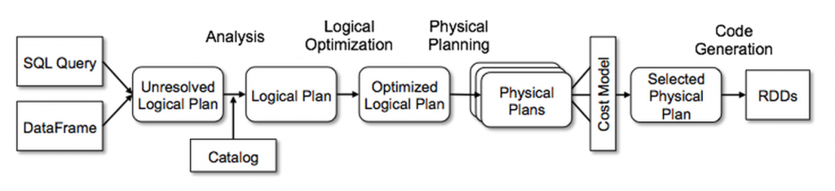
Predicate Pushdown: This technique pushes down filter predicates to the data source to reduce the amount of data processed.
Projection Pushdown: This technique minimizes the amount of data transfer between data source and the Spark engine by eliminating unnecessary fields (cols) from the table scanning process.
Column Pruning: This technique removes unnecessary columns from the operations to reduce the amount of data processed.
Join Reordering: This technique reorders the join operations to minimize the amount of data shuffled between nodes.
Constant Folding: This technique evaluates constant expressions at compile time to reduce the amount of computation performed at runtime.
Subquery Optimization: This technique optimizes subqueries to reduce the amount of data processed.
Logical planning:
Optimizing the Logical Plan: Once the logical plan is resolved, Catalyst applies a series of optimization rules to improve its efficiency without changing its meaning.
- Predicate Pushdown: Moving filters (WHERE clauses) as early as possible in the plan to reduce the amount of data processed in subsequent steps.
- Column Pruning: Removing columns that are not needed for the final result, reducing the data read and shuffled.
- Constant Folding: Evaluating constant expressions at compile time instead of runtime.
df.selectExpr("col1 + 5 * 2 as result").show() # 5 * 2 is calculated to 10 at compile time
df.selectExpr("'abc' + 'def' as result").show() # "abc" + "def" is evaluated to "abcdef"
df.selectExpr("CASE WHEN 2 > 1 THEN 1 ELSE 0 END as result").show() # The condition 2 > 1 is always true, resulting in 1
- Join Reordering: Finding the most efficient order for joining multiple tables.
- Eliminating Common Subexpressions: Identifying and removing redundant computations.
These optimizations are applied repeatedly until the plan reaches a fixed point where no further improvements can be made.
Physical Plan Generation and Selection: This is where Catalyst translates the optimized logical plan into one or more physical execution plans and then selects the most efficient one.
- Cost-Based Optimization (CBO): In more recent versions of Spark, Catalyst can use statistics (like table size, distinct values, data distribution) to estimate the cost of different physical plans and choose the one with the lowest estimated cost.
- Physical Plan Generation: Creating multiple alternative physical execution plans based on the optimized logical plan. For example, a logical "Join" operator could be translated into a "Sort-Merge Join," "Broadcast Hash Join," or "Shuffle Hash Join" physical operator. The choice depends on factors like data size, distribution, and available memory.
Project Tungsten (memory optimization) includes a code generation framework that translates parts of Spark's physical execution plan into highly optimized bytecode.
available executor slots into pools, and each pool gets a minimum guaranteed share of resources. Within a pool, tasks from different jobs are scheduled in a round-robin or weighted fashion to ensure fairness.
Pyspark Read and Write Modes:
PySpark Read Modes
Read Mode | Default | Behavior | Example
PERMISSIVE | ✅ Yes | Keeps malformed records, sets bad fields as null, stores raw record in _corrupt_record | spark.read.option("mode","PERMISSIVE").csv(path)
DROPMALFORMED | ❌ No | Drops rows that do not match the schema | spark.read.option("mode","DROPMALFORMED").csv(path)
FAILFAST | ❌ No | Fails immediately on malformed record | spark.read.option("mode","FAILFAST").csv(path)
PySpark Write Modes
Write Mode | Default | Behavior | Example
error / errorifexists | ✅ Yes | Fails if output path already exists | df.write.mode("error").parquet(path)
Overwrite | ❌ No | Deletes existing data and writes new data | df.write.mode("overwrite").parquet(path)
Append | ❌ No | Adds data to existing path | df.write.mode("append").parquet(path)
Ignore | ❌ No | Skips write if data already exists | df.write.mode("ignore").parquet(path)
Apache Spark Deployment Modes
* Client Mode (Driver in local machine)
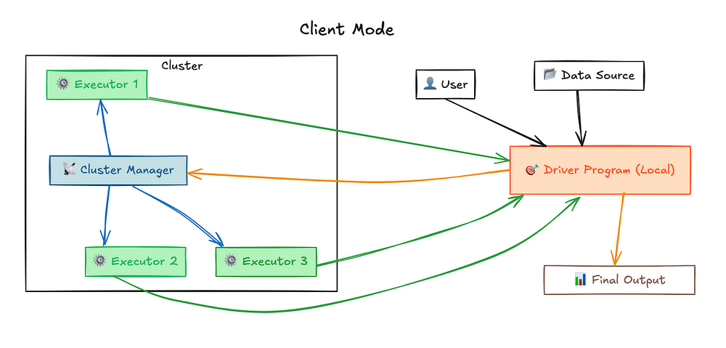
*Cluster Mode: (Driver in Cluster)
Once you submit a job in Cluster-Mode, the Cluster Manager assigns the driver program to one of the worker nodes in the cluster
Cluster Mode’s driver program runs on a separate machine within the cluster, not your local machine. This means the Cluster Manager is responsible for scheduling jobs, allocating resources, and ensuring everything runs smoothly.
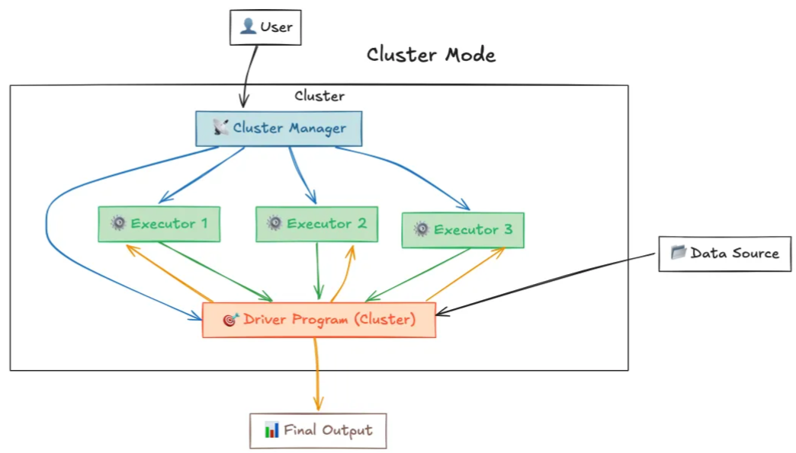
Local Mode (Drivers and Executors in Local machine)
In Spark's local mode, there is no actual cluster manager involved. The driver (the main Spark program) runs on the client machine, and all tasks are executed locally on the same machine
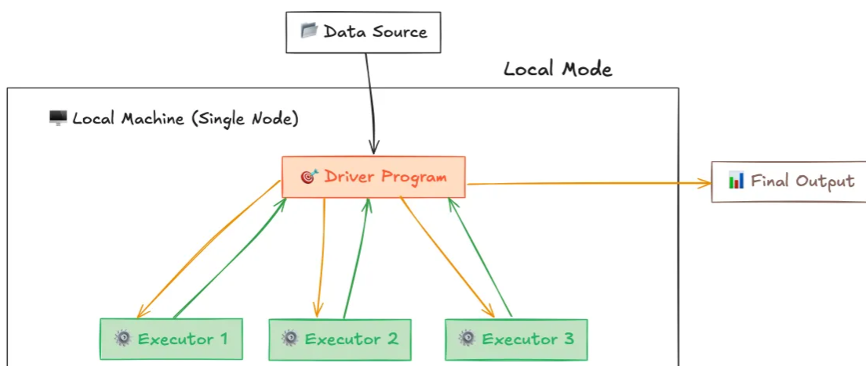

Spark Key Configurations
Static vs Dynamic Memory COnfigurations
Driver/Worker OOM Error Scenarios

Spark Memory
https://raulsanmartin.me/big/data/spark-memory-fundamentals-executor-allocation/
One of the key reasons Spark revolutionized big data processing is its ability to keep data in memory rather than constantly reading from and writing to disk. The speed difference is huge:
Storage Medium | Typical Speed | Relative Performance
DDR4/DDR5 RAM | 20-60 GB/s | 200-600x faster than HDD
NVMe SSD | 3-7 GB/s | 30-70x faster than HDD
SATA SSD | 200-550 MB/s | 2-5x faster than HDD
HDD (7200 RPM) | 80-160 MB/s | Baseline
Gigabit Network | ~100-115 MB/s | Similar to HDD
Note: These values represent typical modern hardware. Actual performance varies by specific hardware generation, configuration, and workload patterns.
Data access speeds: RAM provides orders of magnitude better performance than disk or network storage.
This massive performance advantage makes memory management not just an optimization concern, but a fundamental aspect of Spark application design. Get it wrong and your job will crawl; get it right and you’ll wonder why anyone still uses MapReduce.
The memory management hierarchy
Memory management in Spark isn’t just one thing—it operates at multiple levels:
- Operating System level: Physical RAM management and virtual memory
- Cluster Manager level (YARN/Kubernetes/Mesos): Container resource allocation
- JVM level: Heap management and garbage collection
- Spark level: Unified memory management within executors
When you configure Spark memory settings, you’re primarily working at the Spark and JVM levels, but these decisions ripple through the entire stack. Understanding this hierarchy helps explain why memory issues can show up in weird ways.
How executor memory actually works
In Apache Spark, each executor’s memory is divided into several regions, each with a specific job. When Spark runs on cluster managers like YARN or Kubernetes, it requests containers to execute work. Each executor runs as a separate JVM process within these containers.
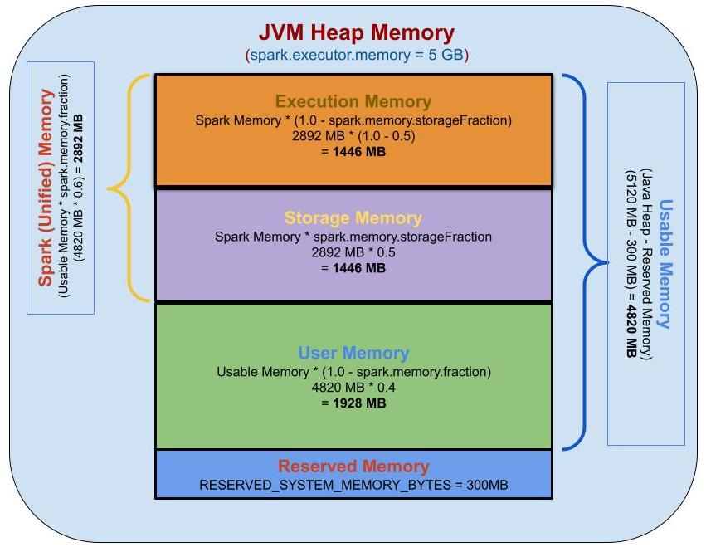
Tip: Execution memory is shared by all the cores allocated to the executor. • Each task (≈ one core) dynamically requests memory when needed Memory is granted on demand, not reserved upfront per core.

Total container memory
The total memory requested from the cluster manager isn’t just the executor memory—there’s more to it:
TotalContainerMemory=
ExecutorMemory+MemoryOverhead+Off-HeapMemory(ifenabled)+PySparkMemory(ifconfigured)
Note: All these components are additive. If any are not configured, they default to 0 and don’t consume additional memory.
Let’s break this down piece by piece.
Memory overhead
Before Spark can use memory for its operations, it reserves a chunk for memory overhead. Think of this as the “tax” Spark pays to the JVM and the operating system. This overhead covers:
- JVM internal operations: Metadata and internal JVM structures
- Interned strings: String pool memory
- Native libraries: Non-JVM operations (like Netty for networking)
- Thread stacks: Memory for executor threads
- PySpark processes: Python interpreter memory when using PySpark. When spark.executor.pyspark.memory is explicitly configured, it becomes a separate memory allocation beyond spark.executor.memoryOverhead; otherwise, Python processes consume part of the overhead memory.
The formula is pretty straightforward:
MemoryOverhead = max⁡(ExecutorMemory ×0.1, 384 MB)
So it’s basically 10% of your executor memory, with a minimum of 384 MB. Let’s see some examples:
- If executor memory is 5 GB: overhead = max(5120 MB × 0.1, 384 MB) = 512 MB
- If executor memory is 1 GB: overhead = max(1024 MB × 0.1, 384 MB) = 384 MB
- If executor memory is 10 GB: overhead = max(10240 MB × 0.1, 384 MB) = 1024 MB
You can explicitly configure this using spark.executor.memoryOverhead. One important thing: starting from Spark 3.0, off-heap memory (spark.memory.offHeap.size) is calculated independently and is NOT included in spark.executor.memoryOverhead. However, both are additive to the total container memory—meaning the container size is the sum of executor memory, overhead, off-heap memory, and PySpark memory if applicable.
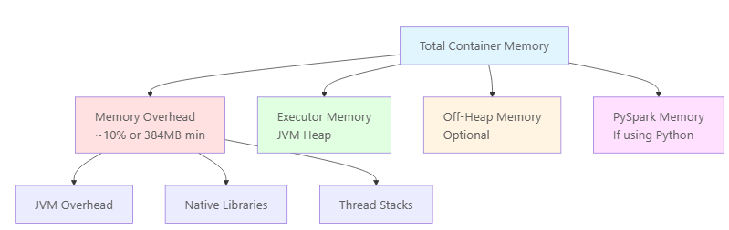
On-heap vs off-heap memory
Spark supports two types of memory allocation; choosing between them can be important depending on your workload:
On-heap memory (the default):
- Managed by the Java Virtual Machine (JVM)
- Subject to garbage collection
- Easier to configure and debug
- Can introduce GC pauses in processing
Off-heap memory (optional):
- Allocated outside the JVM heap using Java’s sun.misc.Unsafe API
- Not subject to garbage collection
- More predictable performance for certain workloads
- Enabled with spark.memory.offHeap.enabled=true
- Size configured with spark.memory.offHeap.size
The unified memory manager
Since Spark 1.6, the platform uses Unified Memory Management, which replaced the older Static Memory Management model. This is a pretty big deal, so let’s talk about why it matters.
The old way: Static Memory Manager
Before Spark 1.6, memory management was handled by StaticMemoryManager, and it had some serious limitations:
- Storage and execution memory had fixed sizes defined at startup
- No dynamic borrowing between regions
- Often led to inefficient memory utilization (one region starving while another had plenty of free space)
- Required manual tuning of separate parameters for different workloads
The UnifiedMemoryManager fixes these issues through dynamic memory sharing. While you can still enable the legacy mode with spark.memory.useLegacyMode=true, this is strongly discouraged. It only exists for backward compatibility and you really shouldn’t use it.
How memory is actually divided
Within the executor memory (JVM heap), Spark divides the space into several regions. Let’s see how:
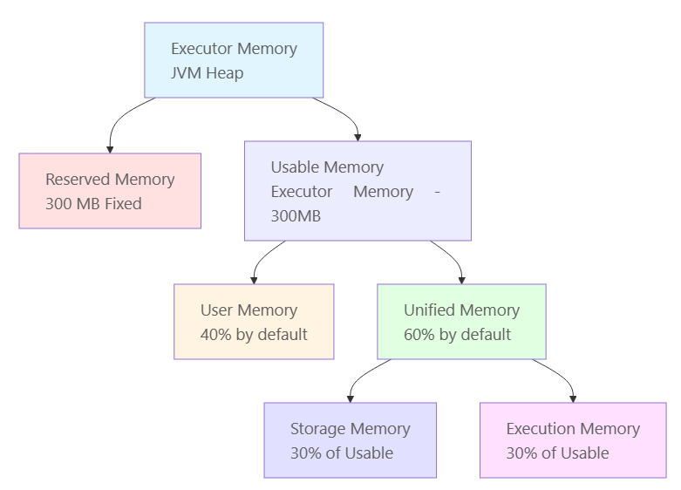
1. Reserved memory (300 MB)
A fixed 300 MB is reserved for Spark internals and system operations. This value is hardcoded in the Spark source code as RESERVED_SYSTEM_MEMORY_BYTES. Think of it as Spark’s safety net—it ensures that Spark has enough space to function even when things get tight.
Important: If the executor memory is less than 1.5 times the reserved memory (i.e., less than 450 MB), Spark will fail with a “please use larger heap size” error. Don’t try to run Spark with tiny executors!
The remaining memory after this reservation is called usable memory:
UsableMemory=ExecutorMemory−300 MB
2. User memory
User memory occupies the remaining fraction of usable memory (1 - spark.memory.fraction). With the default setting (spark.memory.fraction=0.6), 40% of usable memory goes to user memory:
UserMemory=UsableMemory×(1−spark.memory.fraction)
Here’s the catch: user memory is completely unmanaged by Spark. It’s the wild west. It stores:
- RDD transformation metadata: Information about dependencies and lineage
- User-defined data structures: Custom objects created in your code
- UDFs (User-Defined Functions): Memory used by custom functions
- Internal Spark metadata: Information for tracking RDD lineage
Critical: Spark does not track what you store here or enforce its boundary. If you exceed this memory, you’ll get OutOfMemoryError exceptions and Spark won’t be able to help you. It’s entirely on you to manage this space wisely.
3. Unified memory region
The unified memory region accounts for 60% of usable memory by default and is where the magic happens—it’s shared dynamically between storage and execution:
UnifiedMemory=UsableMemory×spark.memory.fraction
This is where Spark’s dynamic memory management really shines. The region is initially split equally between storage and execution (controlled by spark.memory.storageFraction, which defaults to 0.5).
Storage memory
Storage memory handles:
- Cached/persisted RDDs and DataFrames: When you call cache() or persist()
- Broadcast variables: Shared read-only data distributed to all executors
- Unroll memory: Temporary space to deserialize serialized blocks into memory
When storage memory needs to free up space, Spark uses a Least Recently Used (LRU) algorithm to kick out cached blocks. How painful eviction is depends on the storage level you choose:
Storage Level | Eviction Cost | Reason
MEMORY_ONLY | High | Evicted data must be recomputed from source
MEMORY_AND_DISK | Medium | Evicted blocks written to disk and can be read back
MEMORY_AND_DISK_SER | Low | Data already serialized, only disk I/O needed
Execution memory:
Execution memory handles the heavy lifting:
- Shuffle operations: Data redistribution across partitions, including intermediate buffers
- Joins: Hash tables for join operations (especially hash joins)
- Sorts: Temporary buffers for sorting operations
- Aggregations: Data structures for grouping and aggregating
This memory pool supports spilling to disk when insufficient memory is available. However, unlike storage memory, blocks from execution memory cannot be forcefully evicted by other tasks. If execution memory is exhausted and can’t borrow from storage, Spark will spill data to disk to keep processing.
Here’s the thing: Most performance issues in Spark stem from insufficient execution memory leading to excessive disk spilling. If you see your jobs crawling, this is often why.
Dynamic memory borrowing (the cool part)
The beauty of unified memory management is its dynamic nature. When one region needs more memory and the other has free space, borrowing happens automatically:

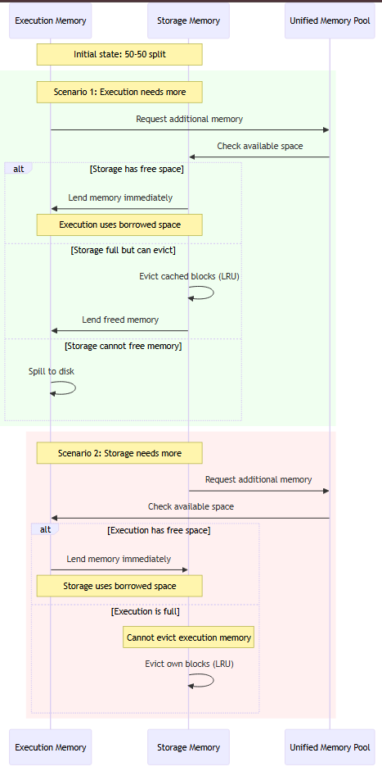
The borrowing rules (pay attention, this is important):
- Execution can borrow from storage: If storage memory has free space, execution can grab it without any restrictions
- Storage can borrow from execution: If execution memory is free, storage can use it
- Execution memory cannot be evicted: When storage needs memory back, it cannot forcibly take it from execution
- Storage memory can be evicted: Cached blocks can be removed using LRU policy to free up space
Why this asymmetry? Simple:
- Execution operations are part of active computations that can’t be interrupted without causing task failures
- Cached data can be recomputed from RDD lineage or read from disk if evicted
Execution wins over storage because a task crash is worse than evicting cached data. Makes sense, right?
A practical example
Let’s walk through a real example with a 12 GB executor to see how all this plays out in practice:
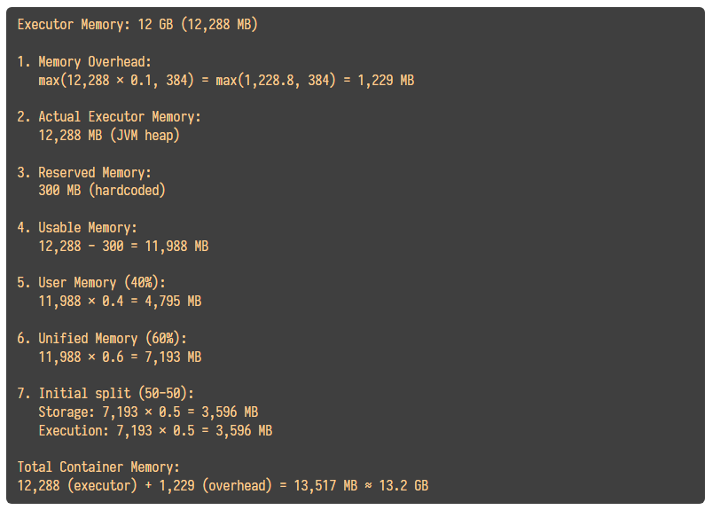

So with these defaults, requesting a 12 GB executor results in about 13.2 GB total container memory. Keep that in mind when planning your resource allocation!
Configuration parameters you should know
Here are the key memory configuration parameters:
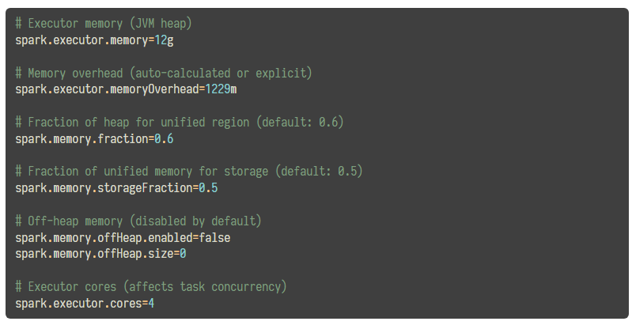
Task-level memory management
While the MemoryManager handles executor-level memory allocation, individual tasks need their fair share too. You don’t want the first task consuming all the memory, right?
TaskMemoryManager
TaskMemoryManager sits between tasks and the MemoryManager. It’s like a middleman that:
- Memory acquisition: Requesting memory from MemoryManager on behalf of tasks
- Memory release: Returning memory when tasks complete
- Accounting: Tracking how much memory each task uses
Memory per task
Tasks within an executor run as threads that share the same JVM. The memory available to each task is managed dynamically through TaskMemoryManager (see [3] for source code) and allocated on-demand from the execution memory pool. This ensures fair distribution of execution memory among concurrent tasks.
With multiple concurrent tasks, memory is allocated dynamically. Each task can acquire memory from the execution memory pool based on availability. When execution memory becomes constrained:
- If a task cannot acquire more memory, it will attempt to spill intermediate data to disk
- Memory becomes available when other tasks complete and release their allocations
- The system prioritizes continued execution over immediate failure
Concurrent Tasks | Memory Allocation | Typical Behavior
1 task | On-demand, up to full execution memory | Single task uses available execution space
2 tasks | Shared on-demand | Both tasks request memory as needed
4 tasks | Shared on-demand | Higher contention, possible disk spilling
8+ tasks | Shared on-demand | Significant contention, likely disk spilling
Takeaway: More concurrent tasks mean less memory per task. This is controlled by spark.executor.cores—fewer cores per executor means fewer concurrent tasks and more memory for each task to work with.
Best practices
Here are some tips to keep your Spark jobs running smoothly:
Partition appropriately: Aim for at least 2-3 partitions per CPU core for good parallelism.
Filter early: Reduce data volume as early as possible in your pipeline. The less data you carry through, the less memory you need.
Cache wisely: Only cache data that will be reused multiple times. Caching everything wastes memory for no benefit.
Choose storage levels carefully:
- MEMORY_ONLY: Fast but risky if data doesn’t fit
- MEMORY_AND_DISK: Safe default with automatic spilling
- MEMORY_ONLY_SER: Save memory with some serialization overhead
- OFF_HEAP: Predictable performance, no GC pressure
Monitor memory usage: Use Spark UI (http://localhost:4040) to keep an eye on:
- Memory usage per executor
- Spill metrics (memory and disk)
- GC time
- Task serialization time

Scenarios that would create memory pressure in executor memory:
• Data skew – one partition contains most records, so a single task holds very large aggregation or shuffle buffers and exhausts execution memory; example: GROUP BY country where one country dominates.
• Large non-broadcast join – Spark builds a big hash table or sort buffers in execution memory that cannot fit; example: joining a large dimension table without broadcast hints or AQE.
• Too many executor cores – many parallel tasks share limited execution memory, reducing per-task memory and increasing spills and OOM risk; example: 8–16 cores with only 8 GB executor memory.
• Wide transformations – operations like groupBy, orderBy, or distinct create large sort and aggregation buffers in execution memory; example: counting users on billions of event rows.
• Excessive caching – heavy use of cache() fills storage memory, increasing GC pressure and reducing headroom for execution memory eviction during shuffles; example: caching multiple intermediate DataFrames.
• Explode or cross join – commands that multiply rows drastically increase shuffle size and per-task memory usage; example: explode(array_col) or CROSS JOIN on two large tables.
• Compressed or zipped input expansion – reading highly compressed files inflates data in memory during decompression; example: processing large GZIP files that expand several times in executor memory.
• Large broadcast variables – broadcasting a dataset that barely fits memory increases pressure on executor heap and can trigger OOM; example: broadcasting a 2–3 GB lookup table.
Scenarios that would create memory pressure in storage memory:
• Over-caching large DataFrames – caching very large datasets fills storage memory quickly, leaving little free space and causing frequent evictions; example: df.cache() on multi-TB fact tables.
• Caching multiple intermediates – persisting many temporary DataFrames without unpersist() accumulates storage blocks and exhausts storage memory; example: caching every step in an ETL pipeline.
• Using MEMORY_ONLY persistence – blocks cannot spill to disk, so when storage memory is insufficient, caching fails and causes recomputation pressure; example: persist(StorageLevel.MEMORY_ONLY) on large data.
• Large broadcast variables – broadcast data is stored in storage memory and can occupy significant space; example: broadcasting a several-GB lookup table across all executors.

Join Strategies

Join Strategy | Notes with Defaults, Sizes, and Decision Inputs
Broadcast Hash Join | • Default broadcast size: 10 MB via spark.sql.autoBroadcastJoinThreshold  • Small table must fully fit into executor memory  • Avoids shuffle; best when large table is highly skewed
Shuffle Hash Join | • Used when one side is smaller but cannot be broadcasted  • Requires high executor memory to hold hash table  • Often disabled by default due to memory instability risks
Sort Merge Join | • Default join strategy when both tables are large  • Requires shuffle and sort on join keys on both sides  • Works best with evenly distributed keys and aligned partitions
Broadcast Nested Loop Join | • Used for non-equality joins like <, >, or !=  • One table must be extremely small to avoid explosion  • Performance degrades exponentially as data size increases
Cartesian (Cross) Join | • Produces output size = left rows × right rows  • Explicitly enabled using spark.sql.crossJoin.enabled=true  • Only safe for tiny datasets or controlled test scenarios
Adaptive Query Execution – Skew Join Handling | • Enabled by default in Spark 3.x via spark.sql.adaptive.enabled=true  • Automatically splits skewed partitions at runtime  • Reduces long-running tasks caused by skewed join keys

Spark Memory Errors in Each Memory Layers:
Memory Type | OOM Scenario | Notes
Driver Memory | Large collect()  df.collect() | Why/When: Entire dataset is deserialized into driver heap. OK for <50 MB; multi-GB causes immediate failure.  Avoid: limit(), take(), write to storage, per-partition logic.  Check UI: Driver logs → sudden failure before tasks finish; few or no executor failures.  Code Clue: Presence of collect() / toLocalIterator().  Error: OutOfMemoryError: Java heap space (driver)
Driver Memory | Driver-side aggregation result  df.groupBy("user_id")  .count().collect() | Why/When: Aggregation output (millions of keys) is large even if input is distributed.  Avoid: Save results instead of collecting.  Check UI: SQL tab → final stage completed, driver fails after result fetch.  Data Clue: High distinct key count.  Error: GC overhead limit exceeded
Driver Memory | Oversized broadcast join  df.join(broadcast(dim_df)) | Why/When: Broadcast table is materialized & serialized on driver (>500 MB is risky).  Avoid: Broadcast only truly small tables; rely on auto broadcast threshold.  Check UI: SQL → “BroadcastExchange” size; Driver logs fail before task execution.  Error: Failed to execute broadcast exchange
Execution Memory | Large shuffle aggregation  df.groupBy("key").sum() | Why/When: Shuffle hash maps exceed executor execution memory; spill insufficient for very large data (>100 GB).  Avoid: Increase shuffle partitions, pre-aggregate, enable AQE.  Check UI: Stages → high shuffle read/write; Tasks tab → multiple task failures on same executor.  Error: ExecutorLostFailure (OOM)
Execution Memory | Skewed join key  df1.join(df2, "user_id") | Why/When: One key owns huge data (10–50 GB); one task handles it → executor OOM.  Avoid: Salting, AQE skew join, filter skewed keys.  Check UI: One task takes much longer; shuffle read size extremely uneven.  Error: Task killed due to OutOfMemoryError
Execution Memory | Global sort  df.orderBy("event_time") | Why/When: Sorting requires large in-memory buffers per partition.  Avoid: sortWithinPartitions(), limit early, avoid global sort.  Check UI: Stage shows “Sort” with high memory spill and shuffle size.  Error: ExternalSorter spilled too much data
Storage Memory | Caching large DataFrame  df.cache() | Why/When: Cached blocks exceed storage region; eviction + GC thrashing → OOM.  Avoid: Cache only reused datasets; unpersist aggressively.  Check UI: Storage tab → cached size near limit; frequent recomputation.  Error: Unable to evict blocks; insufficient memory
Storage Memory | Wrong persist level  df.persist(MEMORY_ONLY) | Why/When: No disk spill; partition doesn’t fit in memory.  Avoid: Use MEMORY_AND_DISK for large datasets.  Check UI: Storage tab → blocks failing to store; executor crashes quickly.  Error: BlockManager failed to store block
Storage Memory | Too many cached datasets  df1.cache(); df2.cache() | Why/When: Heap fragmentation + long GC cycles trigger OOM indirectly.  Avoid: Cache selectively; unpersist() unused DFs.  Check UI: Executors → high GC time, low task throughput.  Error: GC overhead limit exceeded
User Memory | Heavy object creation in UDF  df.withColumn("x", udf_func()) | Why/When: Objects live outside Spark memory manager; cannot be spilled or evicted.  Avoid: Prefer Spark SQL / built-in functions.  Check UI: Executor memory looks fine, but task still fails.  Error: OutOfMemoryError in Python worker
User Memory | Driver-side collections  rows = df.collect() | Why/When: Data duplicated in executor and driver heap.  Avoid: Never store large results locally.  Check UI: Driver crashes while executors look healthy.  Error: OutOfMemoryError: Java heap space
User Memory | Large in-memory structures in mapPartitions() | Why/When: Partition-level lists/maps grow too large before being released.  Avoid: Stream results, clear objects early.  Check UI: One task repeatedly fails on same executor.  Error: Task failed due to OOM
Off-Heap / Native | Arrow-based conversion | Why/When: Native memory exceeds container limit; JVM heap still appears fine.  Avoid: Disable Arrow for large jobs; increase executor overhead.  Check UI: Executor lost without JVM OOM; container memory exceeded.  Error: Container killed for exceeding memory limits
Off-Heap / Native | Native ML / JNI libraries | Why/When: Native allocations bypass Spark memory tracking.  Avoid: Tune executorMemoryOverhead.  Check UI: Executor exit code 137; no Spark OOM trace.  Error: Executor exited with exit code 137
Off-Heap / Native | Shuffle + native memory overlap | Why/When: Heap + off-heap together exceed container memory.  Avoid: Balance executor heap vs overhead.  Check UI: High shuffle + sudden executor loss.  Error: Killed by signal 9 (SIGKILL)

Cache and Persist:
Aspect | cache() | persist()
What it is | Convenience shortcut | Core persistence API
Default behavior | MEMORY_AND_DISK | No default
Storage level choice | Fixed:• MEMORY_AND_DISK | Configurable:• MEMORY_ONLY• MEMORY_ONLY_SER• MEMORY_AND_DISK• MEMORY_AND_DISK_SER• DISK_ONLY• OFF_HEAP
Disk fallback | Always enabled | Depends on chosen level
Serialization control | ❌ Not supported | ✅ Supported (_SER)
Off-heap caching | ❌ Not supported | ✅ Supported
Memory safety | High (disk spill) | Depends on level
Performance tuning | Limited | Fine-grained
Production usage | Exploratory / default use | Recommended for large data
Interview framing | “Shortcut API” | “Tuning & control API”

Unpersist vs clearCache
Aspect | df.unpersist() | spark.catalog.clearCache()
Scope | Single DataFrame | All cached tables & DataFrames
Granularity | Fine-grained | Global
Typical usage | Release memory for one DF | Reset cache state
Affects temp views | Only if tied to DF | ✅ Yes
Risk | Low (targeted) | High (evicts everything)
Production usage | Preferred | Rare, careful use

Spark Static vs Dynamic Resource Allocation
Static Resource Allocation (Fixed executors)
🔹 What it means
- You fix the number of executors at job start
- Spark never increases or decreases them
- Executors stay allocated even if idle
spark-submit \
--conf spark.executor.instances=5 \
--conf spark.executor.cores=4 \
--conf spark.executor.memory=8g
🔹 When static is good
- Predictable workloads. SLA-driven batch jobs
- Legacy YARN setups. Capacity already reserved
Dynamic Resource Allocation (Auto scale executors)
🔹 What it means
- Spark adds executors when work increases
- Spark removes executors when idle
- Better cluster utilization
spark.dynamicAllocation.enabled=true
spark.dynamicAllocation.minExecutors=2
spark.dynamicAllocation.maxExecutors=20
spark.dynamicAllocation.initialExecutors=4
🔹 Simple example
- Job starts → 4 executors
- Heavy shuffle stage → scales to 15
- Final aggregation → scales down to 3
👉 Executors are allocated only when needed.
5️⃣ Static vs Dynamic (Interview Table)
Aspect | Static Allocation | Dynamic Allocation
Executor count | Fixed | Auto scale
Cost efficiency | Low | High
Performance predictability | High | Medium
Cluster utilization | Poor | Excellent
Best for | Stable batch jobs | Multiple concurrent jobs
Default in Databricks | ❌ | ✅

Data Skews and Salting Technique
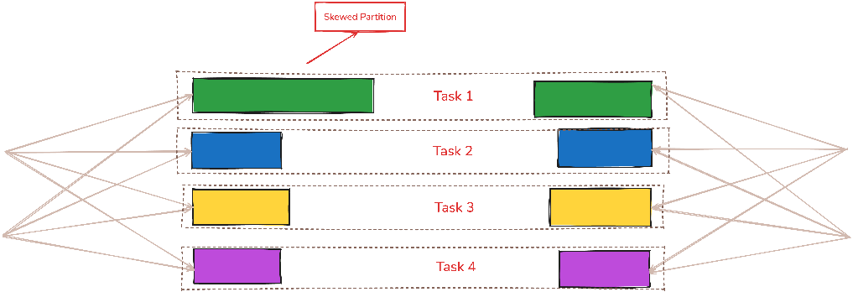
Salting = split something big into smaller pieces
Data skewness happens when some keys have much more data than others, causing:
- One partition to become very large
- One task to run much slower
- Other executors to stay idle
Example: Sales data (join key = country)
country | rows
US | 900 million
UK | 50 million
IN | 30 million
AU | - illion

So when Spark partitions by country, all US rows go to one partition, One executor processes 900M rows, others finish quickly and wait
Salting is a technique to:
- Break one heavy key into multiple keys
- Distribute data across multiple partitions
- Avoid one executor doing all the work
Before salting (skewed):
US → 900M rows → 1 partition
Fix: We add a random salt (0–9): Now 10 executors work in parallel
US_0 → 90M
US_1 → 90M
...
US_9 → 90M

Adaptive Query Execution Features

• Dynamic join strategy switching – When emp data is 50 GB and dept data unexpectedly shrinks to 5 MB, AQE measures the runtime size and automatically broadcasts dept, avoiding shuffle and sort costs.
• Skewed join handling – When emp data is 500 GB and one dept_id = 10 holds 80% of employees, AQE detects the oversized partition and splits it into multiple smaller tasks for parallel execution.
• Shuffle partition coalescing – When filtering reduces emp data from 200 GB to 2 GB, AQE combines many tiny shuffle partitions into fewer larger ones, reducing task scheduling overhead.
• Dynamic shuffle partition sizing – When daily emp data fluctuates between 50 GB and 800 GB, AQE calculates actual shuffle sizes at runtime and creates right-sized partitions instead of using fixed counts.
• Elimination of unnecessary shuffles – When emp data is already partitioned by dept_id and downstream operations use the same key, AQE recognizes compatible partitioning and removes the shuffle stage completely.
• Runtime query plan re-optimization – When Spark initially estimates emp data as 100 GB but runtime statistics show 600 GB, AQE re-optimizes the physical plan using real execution metrics.
• Handling unpredictable workloads – When the same emp job processes 100 GB on normal days and 700 GB on month-end, AQE adapts join strategies, partition counts, and task parallelism dynamically during execution.

Catalyst Optimizer

• Predicate pushdown – For an emp table of 200 GB, applying a filter like country = 'IN' after reading all data wastes I/O, so Catalyst applies the filter during data reading and loads only matching rows.
• Column pruning – For an emp table with 200 columns, when a query uses only 5 columns, Catalyst reads only those columns, reducing disk reads, deserialization, and executor memory usage.
• Join reordering – When joining emp (300 GB), dept (5 GB), and location (1 GB) in written order creates large intermediates, Catalyst changes the join order to process smaller tables first.
• Constant folding – For 100 million emp records, repeatedly computing expressions like salary * 12 + 1000 wastes CPU, so Catalyst precomputes constant parts during planning to reduce per-row computation.
• Logical plan simplification – For layered queries on 200 GB emp data containing redundant filters or projections, Catalyst removes unnecessary operations to create a simpler and faster execution plan.

Cost-Based Optimizer (CBO)
• Join order selection – When joining emp (300 GB), dept (5 GB), and location (1 GB), CBO uses table statistics to join smaller tables first, reducing intermediate data size and shuffle cost.
• Join strategy selection – When statistics show dept data is small enough, CBO chooses a broadcast join instead of a shuffle join to avoid expensive data movement.
• Cardinality estimation – When filters reduce 200 GB emp data to a much smaller subset, CBO estimates the reduced row count to plan joins and aggregations more efficiently.
• Aggregation planning – When aggregating 500 GB sales data by a high-cardinality column like customer_id, CBO selects aggregation strategies that minimize shuffle size and executor memory usage.
• Statistics-driven optimization – When column statistics show only 5% of emp records match a filter like country = 'IN', CBO uses this information to choose more efficient join orders and execution strategies.

Tungsten Execution Engine
• Off-heap memory management – When processing 500 GB emp data, Spark does not load all data into memory; instead, Tungsten stores intermediate execution data (buffers, shuffle blocks, sort data) in off-heap memory outside the JVM heap so garbage collection is minimized while data continues to stream from disk and network in manageable chunks.
• Binary row format – When joining 300 GB emp data with 50 GB salary data, Tungsten represents rows in a compact binary layout rather than JVM objects, drastically reducing per-row memory overhead and improving CPU efficiency during joins and aggregations.

Whole-Stage Code Generation (WSCG)
Simple data-based scenario
- You are processing 300 GB of emp data
- Your query does:
  - filter employees by country
  - select few columns
  - calculate total salary by department
Without Whole-Stage Code Generation
- Spark runs filter, select, and aggregation as separate steps
- For every row, Spark jumps between multiple functions
- This creates extra CPU work and slows down execution
With Whole-Stage Code Generation
- Spark generates one optimized Java code block
- Each row goes through filter, select, and aggregation in one tight loop
- No repeated function calls for every operation

Spark Best Practices
• Enable G1GC for executors because Spark creates many short-lived objects during shuffles; G1GC minimizes long stop-the-world pauses that otherwise cause executor timeouts.
Example: spark.executor.extraJavaOptions=-XX:+UseG1GC
G1GC is a new Garbage-First Garbage Collector, prioritizes predictable, short GC pauses improve task execution stability
• Set a GC pause target to keep executors responsive under memory pressure; uncontrolled GC pauses often look like random task or executor failures.
Example: -XX:MaxGCPauseMillis=200 -> GC will run for only 200 ms (instead of 6 seconds for ex)
• For a 16-GB Databricks worker, prefer one executor per node with balanced cores and memory to avoid GC and shuffle contention.
Example: spark.executor.cores=4, spark.executor.memory=10g, spark.executor.memoryOverhead=2g
• Avoid increasing executor memory as a first fix; large heaps worsen GC pauses, hiding data and partitioning issues instead of solving them.
• Enable Kryo serialization to reduce object size in memory and during shuffle, directly lowering GC pressure and network IO. Example: spark.serializer=org.apache.spark.serializer.KryoSerializer
• Use AQE instead of static shuffle tuning where possible, because runtime coalescing and skew handling prevent oversized shuffle tasks.
Example: spark.sql.adaptive.enabled=true
• Cache only datasets reused across multiple actions, since cached data competes with execution and shuffle memory on executors.
Example: df.persist(MEMORY_AND_DISK)
• Always unpersist cached DataFrames once no longer needed, because forgotten caches are a common hidden cause of executor OOM in long pipelines. Example: df.unpersist()
• Avoid auto broadcast joins for unpredictable table sizes, as accidental broadcasting can instantly exhaust executor memory.
Example: spark.sql.autoBroadcastJoinThreshold=-1 or 10MB (-1 means disable)
• Prefer Spark SQL built-in functions over UDFs, because UDFs bypass Catalyst optimization and increase CPU and memory usage per task.
• Avoid collect() and toPandas() on anything beyond small samples, because all data is pulled into driver memory, frequently causing driver OOM.
• Apply column pruning and predicate pushdown early, because reading unnecessary columns and rows wastes IO and executor memory.
Example: df.select("id","date").filter(col("date") >= "2025-01-01")
• Architect’s rule: if executors show high GC time, spills, or instability, fix data shape, joins, partitioning, and caching first; JVM tuning is the final refinement, not the cure.

Delta Lake
Z-Ordering in Databricks is conceptually similar to a clustered index in RDBMS because both try to physically colocate data based on key columns to improve query performance.
Recommendation: We can partition by Country column and Z-Order based on Invoice-No

 | Clustered Index (SQL Server) | Z-Ordering (Databricks / Delta Lake) | Liquid Clustering (Databricks / Delta Lake)
Create / Enable | CREATE CLUSTERED INDEX IX ON orders(order_date); | OPTIMIZE orders ZORDER BY (order_date); | ALTER TABLE orders CLUSTER BY (order_date);
Physical Behavior | Rows physically sorted in B-tree leaf pages | Rows co-located across Parquet files | Files reclustered adaptively in background
When Applied | During every insert/update operation | Only when OPTIMIZE is executed | Continuously, system-managed
Maintenance Command | ALTER INDEX IX ON orders REBUILD; | OPTIMIZE orders; | No explicit maintenance command
Write Impact | High write cost due to page splits | Write cost only during OPTIMIZE | Minimal incremental rewrite cost
Query Example | WHERE order_date BETWEEN d1 AND d2 | WHERE order_date = '2025-01-10' | Same query, performance improves over time
Execution Benefit | Ordered range scan | File pruning via min/max stats | Adaptive file pruning
Control Level | Full DBA control | Engineer-controlled, manual tuning | Platform-controlled, minimal tuning
Key Limitation | Only one clustered index per table | Requires knowing access patterns upfront | Less deterministic, harder to reason initially
Best Fit | OLTP, predictable access paths | Stable OLAP filters | Evolving, exploratory analytics

Performance difference among
- ZORDER (country + order_date)
- PARTITION BY (country) + ZORDER (order_date)
- PARTION BY (country, order_date) LIQUID Clustering
Note: Partitioning gives the strongest pruning (Exclude unwanted folders in first level)
Dimension | ZORDER(country, order_date) | PARTITION(country) + ZORDER(order_date) | Liquid Clustering(country, order_date)
Directory pruning | ❌ No | ✅ Very strong | ❌ No
File-level pruning | ✅ Yes | ✅ Yes | ✅ Yes (adaptive)
Adaptation to query change | ❌ Manual | ❌ Manual | ✅ Automatic
Rewrite blast radius | Large | Small (per partition) | Incremental, controlled
Operational effort | Medium | High (design + maintenance) | Low
Determinism | High | Very high | Lower (heuristic)
Scalability (TB+) | Medium | Excellent | Excellent
Future-proof | ❌ | ❌ | ✅

Recommended: Liquid Clustering (modern recommendation)
Best architectural choice when:
- Query patterns evolve
- You want minimal tuning
- Large tables (100s GB / TBs)
- Mixed filters (country, date, customer, etc.)
➡️ Slightly less deterministic than partitioning,
➡️ But much safer long-term and Databricks-recommended going forward.

Databricks

Spark vs Databricks
Feature | Spark | Databricks | Key Features
Databricks Runtime | NO | YES | Photon  Run multiple versions of Spark  Built-in optimized for cloud storage  Compute optimizations  Multi-user cluster sharing  Second level billing
Managed Data Lake | NO | YES | ACID Transations  Schema management  Batch/Stream read-write support  Data versioning  Performance optimizations
Integrated Workspace | NO | YES | Interactive Notebooks  Real-time collaboration  Github integration  One-click visualizations
Enterprise Security | NO | YES | Access control for notebooks, clusters, jobs and data  Audit logs  Data encryption (at rest and motion)  Compliance (HIPAA, SOC 2)
Integration | NO | YES | Connect with Power-BI/Tableau via JDBC/ODBC  REST API  Data Source Connectors
Expert Support | NO | YES
Others feature: Delta Lake, Unity Catalog, DLT, MLOps, Cloud Integrations

Unity Catalog

Misc 1

Misc 2

Misc 3

Misc 4

Misc 5

Azure

Azure Services:
Azure VM Types
General purpose (A, B, and D family series): These VMs have a balanced CPU-to-memory ratio. They are best suited for testing and development (A series only), burstable workloads (B series only), and general-purpose workloads (D series only).
Compute optimized (F family series): These VMs have a high CPU-to-memory ratio. They are best suited for web servers, application servers, network appliances, batch processes, and any workload where bottlenecks and a lack of resources will typically originate in the CPU over memory.
• Memory optimized (E and M family series): These VMs have a high memory-to-CPU ratio. They are best suited for relational databases, in-memory analytics, and any workload where bottlenecks and a lack of resources will typically originate in the memory over the CPU.
• Storage optimized (L family series): These VMs have high disk throughput and I/O. They are best suited for data analytics, data warehousing, and any workload where bottlenecks and a lack of resources will typically relate to the disk over the memory and CPU.
• GPU optimized (N family series): These VMs have graphics processing units (GPUs). They are best suited for compute-intensive, graphics-/gaming-intensive, visualization, and video conferencing/streaming workloads.
• High performance (H family series): These are the most powerful CPU VMs that Azure provides, offering high-speed throughput network interfaces. They are best suited for compute and network workloads such as SAP HANA
[Family] + [Sub-Family] + [# of vCPUs] + [Additive Features] + [Version]
VM series naming:
• Family: This represents the VM family series.
• Sub-Family: This represents the specialized VM differentiations.
• # of vCPUs: This represents the number of vCPUs of the VM.
• Additive Features examples:
a = AMD-based processor
b = Block Storage performance
d = diskful (that is, a local temp disk is present);
i = isolated size
l = low memory; a lower amount of memory than the memory intensive size
m = memory intensive; the most amount of memory in a particular size
p = ARM Cpu
t = tiny memory; the smallest amount of memory in a particular size
s = Premium Storage capable, including possible use of Ultra SSD

Some example breakdowns are as follows:
• B2ms: B series family, two vCPUs, memory-intensive, Premium Storage-capable
• D4ds v5: D series family, four vCPUs, local temp disk, Premium Storage-capable, version 5
• D4as v5: D series family, four vCPUs, AMD, Premium Storage-capable, version 5
• E8s v3: E series family, eight vCPUs, Premium Storage-capable, version 3
• NV16as v4: N series family, NVIDIA GRID, 16 vCPUs, AMD, Premium Storage-capable, version 4

Azure VM cost depends on:
- Enterprise level agreements
- Region
- OS (Windows, Linux)
- VM Size and series
- Type of storage (HDD, SSD – standard/premium/ultra
- Azure Hybrid benefit (allows organizations to use their existing on-premises Windows Server and SQL Server licenses)
- Pricing Model
  - Pay as you go
  - Reserved instance
  - Spot Instances
Commonly used Azure VM in Databricks – General Purpose
standard_d16ads_v5
- General purpose VM – AMD based, Temp disk, Premium storage
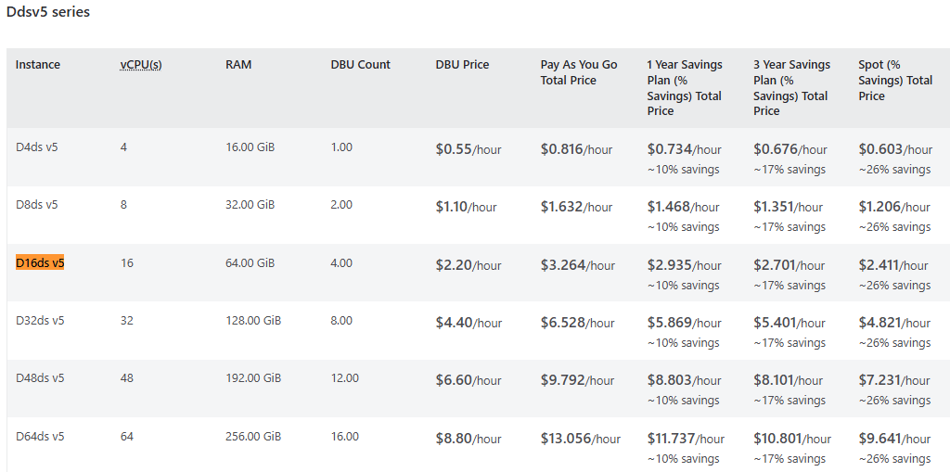

Agile & DevOps
Agile is a project management framework used in software development that focuses on iterative development, continuous improvement, and strong team collaboration. DevOps complements Agile by providing the tools, people, and processes to support Agile principles through automation, continuous integration, and continuous deployment (CI/CD)

What is Agile?
Agile is a project management framework that emphasizes iterative development, continuous improvement and collaborations. It avoids long-term planning and focuses on frequent working releases (SDLC Waterfall).

Scrum vs Kanban
Method | Description | Best Use Case
Scrum | Fixed sprints (usually 2 weeks), planned work with review & retrospective. | Feature development, new products, evolving requirements.
Kanban | No sprint. Visual continuous flow (To Do → In Progress → Done). | Support tasks, bugs, production issues, BAU work.

Agile Terms + Sprint Life Cycle (Example: Python Web App)
Sprint Scenario:
We are building a simple Python-based web application with endpoints, database connection, and UI page. The sprint duration is 2 weeks.
Sprint Stage | What Happens for Python Web App | Effort Calculation
Product Backlog | Features added: login API, DB integration, UI page. | No estimation yet.
User Stories | Example: “As a user, I want to log in using email & password.” | Described in Jira.
Sprint Planning | Team prioritize & selects stories for this sprint. | Estimation → Planning Poker & T-Shirt Sizing.
Effort Estimation | Planning Poker: Team picks story points (1–13)  T-Shirt Sizing: High-level sizing (S, M, L, XL). | Workload for sprint is set.
Task Breakdown | Split story into tasks: create API router, DB model, unit test, UI design. | Each task has hours estimate.
Development | Code written in VS Code → commit via Git → push to GitLab. | Tracked in Jira board.
Daily Standup | Team updates: yesterday / today / blockers. | Burndown chart updates.
Testing | QA runs manual + automation tests. | Bugs added to backlog.
Sprint Review | Python app packaged and demoed. | Stakeholder feedback.
Retrospective | Team discusses improvements for next sprint. | Process improvement.
Next Sprint | Feedback stories added to backlog. | New estimation.

4. Scrum Team Roles
Role | Responsibility
Product Owner | Defines features, sets priority, manages backlog.
Scrum Master | Ensures Scrum process, removes blockers, resolves conflicts.
Developers | Code, review, integration, unit tests, deployments.
QA/Testers | Manual & automation testing, regression checks.
DevOps | DevOps
Architects (optional) | Design scalable structure.
Stakeholders | Provide business feedback during review.

What is DevOps?
DevOps complements Agile by providing the tools, people, and processes to support Agile principles through automation, continuous integration, and continuous deployment (CI/CD)
DevOps focuses on:
- Automation of build, test, deployment, monitoring
- Collaboration between dev, QA, security, and operations
- Fast feedback from production to development
- Infrastructure as Code (IaC) for repeatable and stable environments

CI/CD – Python Web App (End-to-End Flow)
Goal: move code from development → testing → production automatically with reliability.
Stage | Tools | Purpose (Senior Developer Level)
Coding | VS Code | Write APIs, models, and tests for Python app.
Version Control | Git | Track code history, create branches, manage pull requests.
Repo | GitLab | Central source of truth for code + CI pipeline trigger.
CI Pipeline | GitLab CI (.gitlab-ci.yml) | Build app, run unit tests, code quality checks (linting).
Dockerization | Dockerfile | Package app into container – consistent environment.
Image Storage | GitLab Container Registry | Store Docker image for deployments.
Deploy to Dev | Kubernetes | Early testing environment. Used for functional testing.
Deploy to Test | Kubernetes + QA team | Regression testing + automation.
Deploy to Prod | Kubernetes Rolling Update | Zero-downtime deployment.
Monitoring | Grafana / Logs / Alerts | Track performance, issues, downtime.
Feedback | Jira Backlog | Issues move back to next sprint.

Git & GitLab Workflow
Create project, clone in VS Code, create feature branch
On GitLab UI
- Create New Project → “Blank project”.
- Name: e.g. sample-python-webapp.
- Visibility: as you like.
- Click Create project.
On your machine
# Clone the repo
git clone https://gitlab.com/<your-namespace>/sample-python-webapp.git
cd sample-python-webapp
# Open in VS Code
code .
# Create feature branch
git switch -c feature/simple-webapp

2️⃣ Simple web app code (Python + Flask)
Create the following files in the repo.
requirements.txt
flask==3.0.0
pytest==8.0.0
app.py
from flask import Flask
app = Flask(__name__)
@app.route("/")
def index():
return "Hello from GitLab CI Python web app!"
if __name__ == "__main__":
# Local run only (not used in CI)
app.run(host="0.0.0.0", port=5000)
tests/test_app.py
Create folder tests and this file inside:
from app import app
def test_index():
client = app.test_client()
response = client.get("/")
assert response.status_code == 200
assert b"Hello from GitLab CI Python web app!" in response.data
(Optional) .gitignore – to ignore venv, etc.
.venv/
__pycache__/
*.pyc
.pytest_cache/
reports/
👉 To test locally (optional):
python -m venv .venv
source .venv/bin/activate # Windows: .venv\Scripts\activate
pip install -r requirements.txt
python app.py # then open http://127.0.0.1:5000/

3️⃣ .gitlab-ci.yml with stages, jobs, variables, artifacts
Put this at repo root as .gitlab-ci.yml:
# -------------------------------------------------------------------
# Simple Python web app CI pipeline (for learning)
# - stages: build, test
# - features: variables, cache, artifacts, multiple jobs
# - runs on any branch (feature + main)
# -------------------------------------------------------------------

stages:
- build
- test

variables:
VENV_DIR: ".venv"
REPORT_DIR: "reports"

default:
image: python:3.11-slim
before_script:
- echo ">> Before script for $CI_JOB_NAME"
- python --version
- mkdir -p $REPORT_DIR

cache:
# Cache virtualenv & pip cache to speed up subsequent jobs
paths:
- $VENV_DIR/
- .cache/pip/

# -------------------------------
# BUILD JOB
# -------------------------------
build_app:
stage: build
script:
- echo "Creating virtualenv and installing dependencies..."
- python -m venv $VENV_DIR
- . $VENV_DIR/bin/activate
- pip install --upgrade pip
- pip install -r requirements.txt

- echo "Running basic syntax check..."
- python -m py_compile app.py

artifacts:
# We don't usually store venv as artifact in real projects,
# but this is useful for learning how artifacts work.
paths:
- $VENV_DIR/
expire_in: 1 week
when: on_success

# Run on all branches
rules:
- when: always

# -------------------------------
# TEST JOB
# -------------------------------
test_app:
stage: test
needs: ["build_app"] # Ensure build_app runs first
script:
- echo "Activating virtualenv..."
- . $VENV_DIR/bin/activate

- echo "Checking required files..."
- test -f app.py
- test -f requirements.txt
- test -f tests/test_app.py

- echo "Running tests with pytest..."
- mkdir -p $REPORT_DIR
- pytest -q --maxfail=1 --disable-warnings --junitxml=$REPORT_DIR/junit.xml

- echo "All tests completed" | tee $REPORT_DIR/summary.txt

artifacts:
paths:
- $REPORT_DIR/
when: always
expire_in: 1 week

rules:
- when: always

4️⃣ Check in code and push to remote feature branch
In your repo folder:
git status # verify new files
git add app.py requirements.txt tests/ .gitlab-ci.yml .gitignore
git commit -m "Add simple Flask web app and GitLab CI pipeline"
git push -u origin feature/simple-webapp
This push to feature branch will trigger CI pipeline (build + test jobs).
You can see it in GitLab: CI/CD → Pipelines.

5️⃣ Raise Merge Request (MR) and approve
- Go to GitLab project → you should see a banner:
  - “Create merge request for feature/simple-webapp”
- Click Create merge request.
- Source branch: feature/simple-webapp
Target branch: main
- Add title, description.
- Click Submit / Create merge request.
- Approve the MR (you / reviewer).
- Click Merge.

6️⃣ Pipeline on main after merge
After merge:
- GitLab creates a new commit on main.
- The same .gitlab-ci.yml runs again on main.
- You’ll see another pipeline under CI/CD for branch main.

Commonly Used Git Commands
#==============================================================
# GIT – DAILY USAGE + INTERVIEW REVISION + REAL DEV WORKFLOW
#==============================================================

# -------------------------------
# 1. CONFIGURATION (ONE TIME SETUP)
# -------------------------------
git config --global user.name "Your Name"
git config --global user.email "your.email@example.com"
git config --global core.autocrlf input # Linux/Mac
git config --global core.autocrlf true # Windows
git config --list # View current config

# -------------------------------
# 2. INITIAL SETUP & CLONE
# -------------------------------
git clone <repo-url> # Clone existing repo
git clone -b <branch-name> <repo-url> # Clone specific branch

git init # Initialize new repo (local)
git remote add origin <repo-url> # Link to remote repo
git remote -v # Show remote URLs

# -------------------------------
# 3. BRANCHING (use 'git switch')
# -------------------------------
git switch -c feature/login_page # Create NEW branch & switch
git switch main # Switch to existing branch
git branch # List branches
git branch -d old_branch # Delete LOCAL branch
git branch -D old_branch # Force delete

# -------------------------------
# 4. STATUS & ADD/COMMIT/PUSH
# -------------------------------
git status # Check changes
git add file1.py # Stage single file
git add . # Stage all changes
git commit -m "Add login API" # Commit staged files
git commit --amend # Modify last commit message

git push -u origin feature/login_page # First push for new branch
git push # Normal push
git pull # Pull latest changes

# -------------------------------
# 5. WORKING WITH REMOTE
# -------------------------------
git fetch # Fetch latest changes only
git pull origin main # Pull from remote = fetch+merge
git push origin --delete old_branch # Delete remote branch
git remote show origin # Show remote branch info

# -------------------------------
# 6. STASH (Temporary Save)
# -------------------------------
git stash # Save work without commit
git stash list # List stashes
git stash apply stash@{0} # Apply specific stash
git stash pop # Apply + delete stash
git stash drop stash@{0} # Delete stash

# -------------------------------
# 7. DIFF & LOGS
# -------------------------------
git diff # Compare working vs staged
git diff --cached # Compare staged vs last commit
git diff <branch1>..<branch2> # Compare branches

git log # View commit history
git log --oneline --graph --decorate # Clean view
git log -p # View file changes
git show <commit-id> # View single commit details

# -------------------------------
# 8. MERGE & REBASE
# -------------------------------
git switch main
git merge feature/login_page # Merge branch into main
git rebase main # Replay commits on top of main
git merge --abort # Cancel merge (if conflicts)

# -------------------------------
# 9. REVERT & RESET
# -------------------------------
git revert <commit-id> # Create REVERSE commit
git reset --soft HEAD~1 # Undo commit but keep changes
git reset --hard HEAD~1 # Undo commit AND remove changes
git reset --hard origin/main # Reset to remote copy

# -------------------------------
# 10. TAGS (for releases)
# -------------------------------
git tag -a v1.0 -m "Release version 1.0"
git tag # List tags
git show v1.0 # Details of tag
git push origin v1.0 # Push tag to remote

# -------------------------------
# 11. CHERRY PICK (copy specific commit)
# -------------------------------
git cherry-pick <commit-id> # Copy commit to current branch

# -------------------------------
# 12. CLEANUP
# -------------------------------
git clean -fd # Delete untracked files
git gc # Optimize local repo

Docker – End-to-End Development & CI Workflow
🧠 What is Docker?
Docker is a lightweight container platform that allows developers to package an application with its dependencies and run it exactly the same in all environments — dev, QA, prod, cloud, or local.

⭐ Key Features (Why Senior DevOps Engineers Use It Daily)
Feature | Purpose
Containerization | Run apps in isolated, lightweight environments
Portability | Works the same in local, cloud, dev, prod
Image-based deployment | One Docker image can be reused anywhere
Reproducibility | CI/CD runs the same every time
Resource efficiency | Faster than a VM
Registry support | Push/pull images from GitLab/ DockerHub/ ECR
Easy rollback | Just run older container version

Docker lifecycle (Registry -> Image -> Container)
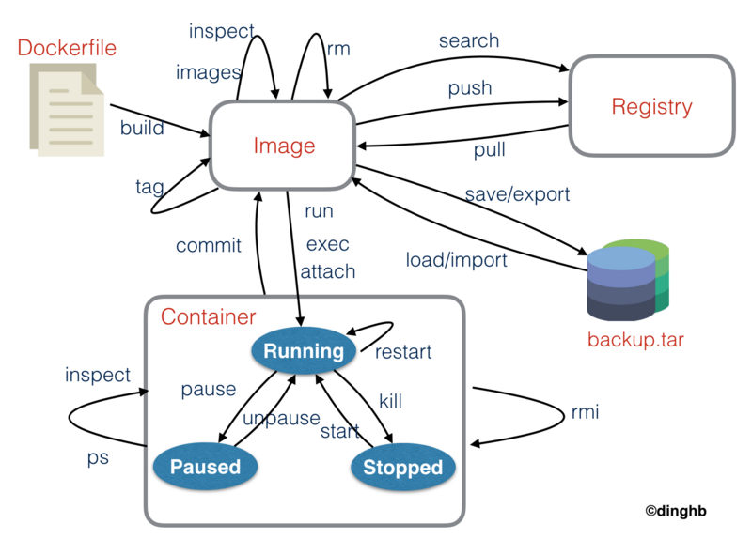

🧩 Simple Web App (Python Flask)
app.py
from flask import Flask

app = Flask(__name__)

@app.route("/")
def index():
return "Hello from Docker-based CI pipeline!"

if __name__ == "__main__":
app.run(host="0.0.0.0", port=5000)
requirements.txt
flask==3.0.0

🐳 Dockerfile
# Base image
FROM python:3.11-slim
# Set working directory inside container
WORKDIR /app
# Copy dependency file & install dependencies
COPY requirements.txt .
RUN pip install -r requirements.txt
# Copy source code
COPY . .
# Run app on port 5000
CMD ["python", "app.py"]

🔥 ALL Important Docker Commands — in One Script Block
# ----- 1) Build an image -----
docker build -t myapp:1.0 .
# ----- 2) List images -----
docker images
# ----- 3) Run container (detached mode + port) -----
docker run -d --name mycontainer -p 5000:5000 myapp:1.0
# ----- 4) Check running containers -----
docker ps
# ----- 5) Check all containers (including stopped) -----
docker ps -a
# ----- 6) Enter container shell (debugging) -----
docker exec -it mycontainer /bin/bash
# ----- 7) Check container logs -----
docker logs mycontainer
# ----- 8) Pause and unpause -----
docker pause mycontainer
docker unpause mycontainer
# ----- 9) Stop container -----
docker stop mycontainer
# ----- 10) Start stopped container -----
docker start mycontainer
# ----- 11) Restart container -----
docker restart mycontainer
# ----- 12) Remove container -----
docker rm mycontainer
# ----- 13) Remove image -----
docker rmi myapp:1.0
# ===== Working with Docker Hub / Registry =====
docker login
docker tag myapp:1.0 mydockerhubuser/myapp:1.0
docker push mydockerhubuser/myapp:1.0
docker pull mydockerhubuser/myapp:1.0
# ===== Listing networks & volumes =====
docker network ls
docker volume ls
# Create network & connect containers
docker network create mynet
docker network connect mynet mycontainer
# ===== Clean up =====
docker rm -f $(docker ps -aq) # remove all containers
docker rmi -f $(docker images -aq) # remove all images
docker system prune -a # remove everything unused
# ===== Build and test locally =====
docker build -t webapp:v1 .
docker run -d -p 5000:5000 --name webapp_container webapp:v1
curl http://localhost:5000 # test

🧪 Testing in Browser After Container Starts
➡ Run:
docker run -d -p 5000:5000 myapp:1.0
➡ Open browser:
http://localhost:5000/

🔄 Typical DevOps Workflow (Simple Daily Flow)
developer writes code → docker build → docker run locally → unit tests
↓
push to GitLab → CI pipeline builds image → test container
↓
push to registry (Hub / GitLab / ECR)
↓
deploy to staging → approval → deploy to prod

🔁 (OPTIONAL) GitLab CI/CD to Build Docker Image
.gitlab-ci.yml
stages:
- build
- test
- push

variables:
IMAGE_NAME: "$CI_REGISTRY_IMAGE/app"
IMAGE_TAG: "v1"

build_image:
stage: build
image: docker:latest
services:
- docker:dind
script:
- docker build -t $IMAGE_NAME:$IMAGE_TAG .
- docker images

test_container:
stage: test
script:
- docker run -d -p 5000:5000 --name testapp $IMAGE_NAME:$IMAGE_TAG
- sleep 5
- curl http://localhost:5000

push_registry:
stage: push
script:
- docker login -u $CI_REGISTRY_USER -p $CI_REGISTRY_PASSWORD $CI_REGISTRY
- docker push $IMAGE_NAME:$IMAGE_TAG

Misc

Parquet Anatomy
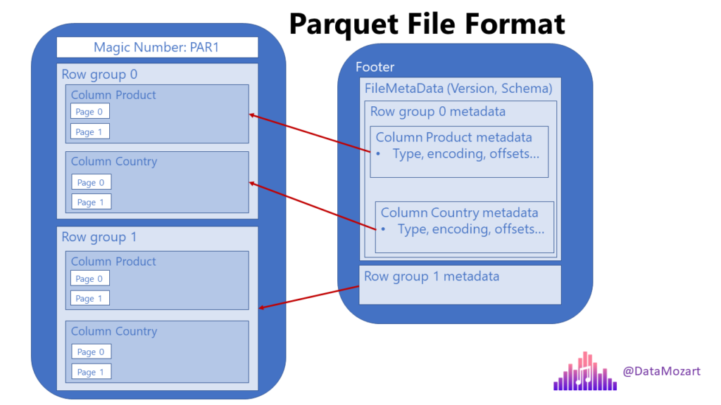

• Key Parquet interview points?
Parquet is columnar, splittable, row-group based, snappy compressed, read-optimized, and sensitive to file sizing.
• What is the recommended Parquet file size in Databricks?
256 MB to 1 GB is recommended for balanced IO efficiency, parallelism, and cloud object storage performance.
• Small number of large workers vs many small workers?
Many moderately sized workers are better for parallelism, fault tolerance, autoscaling, and cost efficiency.
• What happens when a DataFrame is written as Parquet?
Spark plans the write, launches tasks per partition, converts rows to columnar format, builds row groups, compresses, and writes files.
• How many row groups should a Parquet file ideally have?
Multiple row groups per file are ideal, typically 2–8, depending on file size.
• In many small Parquet files, how many row groups per file?
Usually only one partial row group per file.
• Does Spark split Parquet files by row groups?
Yes logically, but Spark may group multiple row groups into a single task depending on configuration.
• Do large datasets mostly have less than 1 TB data?
There is no proof, but practically most datasets are under 1 TB, while few large ones dominate volume.
• What is the problem with a 100 GB Parquet file?
It limits effective parallelism, creates heavy tasks, increases failure impact, and reduces scalability.
• Does one 100 GB Parquet file mean one machine processes it?
No. Multiple machines can read different row groups in parallel, but parallelism is limited and inefficient.
• What does spark.sql.files.maxPartitionBytes do?
It controls how much file data Spark assigns to one scan task by grouping row groups.
• Do tasks process many row groups with optimal Parquet files?
Usually no. With well-sized files, tasks often process one or few row groups.
• Can multiple tasks read row groups from the same Parquet file?
Yes. Different tasks can read different row groups from the same file concurrently.
• Does each row group require a separate worker in Databricks?
No. one row group per task per core. One executor per worker can run multiple row-group tasks using multiple cores.
• Why is a very large Parquet file still a performance problem?
Spark creates fewer, heavier tasks, causing stragglers, poor load balancing, and expensive retries.
• Is reading many optimal Parquet files more IO-efficient than one huge file?
Yes. Multiple files provide better IO parallelism, load distribution, and object storage throughput.
• What does blast radius mean?
Blast radius is how much data and how many tasks are affected when a failure occurs.
• Does Parquet prevent data skew because row groups are 128 MB?
No. Row groups prevent scan-time skew, but shuffle-time skew is unbounded.
• Does skew mostly happen in memory rather than during Parquet reads?
Yes. Skew mainly occurs during shuffle operations like joins and aggregations, not during file scanning.
Why 128 MB – 1 GB is considered as the optimal size for parquet files
File Size | Behavior
< 64 MB | Too many small files (scheduler overhead)
128–256 MB | Best balance for parallelism and pruning
512 MB–1 GB | Acceptable for large scans
> 1–2 GB | Parallelism, pruning, maintenance degrade

OOPS (Problem with Functional programming and how OOPS address those)
Summary:
When software becomes very large (millions of lines, many teams), the biggest problem is coordination and change. If everything is written in one big procedural codebase, a small change by one team can accidentally break another team’s work.
OOP solves this by:
Breaking the system into independent, self-contained components (objects)
Giving each component clear responsibilities and boundaries
Allowing teams to work in parallel without stepping on each other
Key OOP Properties — Interview Summary
OOP Property | Notes (Explanation + Example)
Encapsulation | What: Bundling state and behavior together and hiding internal details.  Why: Prevents uncontrolled state mutation and protects invariants.  class Account:  def __init__(self, balance):  self._balance = balance  def withdraw(self, amt):  self._balance -= amt
Abstraction | What: Exposing only what the user needs, hiding how it works internally.  Why: Reduces cognitive load and dependency on implementation details.  class PaymentService:  def pay(self, amount):  pass # caller doesn't know how payment works\n
Inheritance | What: Creating new classes by extending existing ones.  Why: Promotes code reuse and shared behavior.  Risk: Tight coupling if overused.  class SavingsAccount(Account):  def add_interest(self):  pass
Polymorphism | What: Same interface, different behavior at runtime.  Why: Enables flexible and extensible designs.  class CardPayment:  def pay(self, amt): pass  class UpiPayment:  def pay(self, amt): pass
Data Hiding | What: Restricting direct access to internal state.  Why: Prevents invalid or inconsistent state changes.  self._balance # internal, not public
Single Responsibility Principle (SRP) | What: One class should have one reason to change.  Why: Easier maintenance and safer changes.  class Invoice:  def calculate_total(self):  pass
Open–Closed Principle (OCP) | What: Open for extension, closed for modification.  Why: Add new behavior without touching tested code.  class Payment:  def pay(self): pass

BEFORE OOP: Procedural design (hard to scale)
# Global state shared by everything
vehicle_state = {
"gps_on": False,
"camera_on": False,
"ac_temp": 22,
"media_playing": False
}

def start_gps():
vehicle_state["gps_on"] = True
def stop_gps():
vehicle_state["gps_on"] = False
def start_camera():
vehicle_state["camera_on"] = True
def set_ac_temperature(temp):
vehicle_state["ac_temp"] = temp
def play_media():
vehicle_state["media_playing"] = True
# Main controller
def run_vehicle():
start_gps()
start_camera()
set_ac_temperature(20)
play_media()

What goes wrong at scale?
- All teams modify shared global state
- One team changes vehicle_state → other code breaks
- No clear ownership:
  - GPS team touching camera state
  - UI team touching AC logic
- Reuse is hard — code is tangled
- Testing is painful
👉 This approach collapses with millions of lines and many teams.

AFTER OOP: Object-oriented design (scalable)
class GPS:
def start(self):
print("GPS started")
def stop(self):
print("GPS stopped")

class DashCamera:
def start(self):
print("Camera recording started")

class AirConditioner:
def set_temperature(self, temp):
print(f"AC temperature set to {temp}")

class MediaPlayer:
def play(self):
print("Media playing")
class VehicleController:
def __init__(self):
self.gps = GPS()
self.camera = DashCamera()
self.ac = AirConditioner()
self.media = MediaPlayer()

def start_vehicle(self):
self.gps.start()
self.camera.start()
self.ac.set_temperature(20)
self.media.play()

Why this works so well (key OOP benefits)
✅ Clear ownership
- GPS team works only on GPS
- AC team works only on AirConditioner
- No shared global state
✅ Safe parallel development
- Teams work independently
- Changes are isolated
- Low risk of accidental breakage
✅ Easy upgrades
- Update GPS logic → no impact on camera or AC
- Replace MediaPlayer → controller stays the same

Problem 1: Coordination and change management at large scale
Problem statement (Functional Programming)
In massive banking codebases, procedural design causes tight coupling where small changes by one team can unintentionally break other teams’ functionality.
# Functional style (shared banking utility)
def calculate_balance(account):
# Used by many teams
return account["balance"]
How OOP solves it
OOP introduces clear boundaries through classes and interfaces, allowing teams to work independently with minimal risk of cross-team breakage.

# OOP style (solution)

class BankAccount:
def __init__(self, balance):
self._balance = balance

def get_balance(self):
# ✅ Internal change does not affect other teams
return self._balance

Problem 2: Weak data security and encapsulation
In procedural banking systems, sensitive financial data is exposed and can be modified directly by any function.
# Functional style (banking)
account = {"balance": 1000}
# Direct access to sensitive data
account["balance"] = -500
How OOP solves it
OOP encapsulates banking data inside classes, exposing only safe operations and preventing unauthorized or invalid access.
# OOP style (solution)
class SecureBankAccount:
def __init__(self, balance):
self._balance = balance # ✅ hidden state

def withdraw(self, amount):
if amount > self._balance:
raise ValueError("Invalid transaction")
self._balance -= amount

Problem 3: Lack of code reusability and modularity
Procedural banking systems duplicate logic across functions, making reuse difficult and increasing maintenance cost.

# Functional style (banking)
def savings_interest(balance):
# ❌ Logic duplicated across account types
return balance * 0.04
def current_interest(balance):
# ❌ Similar logic rewritten
return balance * 0.03
How OOP solves it
OOP enables reuse through inheritance and composition, allowing new banking products to be built from existing, tested components.
# OOP style (solution)
class BankAccount:
def calculate_interest(self):
raise NotImplementedError()

class SavingsAccount(BankAccount):
def calculate_interest(self):
return self._balance * 0.04

class FixedDepositAccount(BankAccount):
def calculate_interest(self):
return self._balance * 0.06

Problem 4: Difficulty modeling real-world banking entities
Functional programming struggles to naturally model real-world banking entities whose identity, state, and behavior evolve together over time.

# Functional style (banking)
customer = {"id": "C1", "active": True}
def close_account(customer):
# Behavior is detached from the entity
customer["active"] = False

How OOP solves it
OOP mirrors real-world banking concepts directly, making systems easier to design, reason about, and communicate across teams.
# OOP style (solution)
class BankCustomer:
def __init__(self):
self.active = True

def close_account(self):
# Behavior belongs to the customer entity
self.active = False

def is_active(self):
return self.active

Problem 5: No ownership of data and behavior (Banking domain)
In functional or procedural systems, banking data and operations are separated, making it unclear which component owns and protects critical financial state.
# Functional / procedural style (banking)
accounts = {"A1": 1000}
def withdraw(accounts, account_id, amount):
# ❌ No owner of account balance
# ❌ Any function can mutate balance
accounts[account_id] -= amount

How OOP solves it
OOP assigns clear ownership by binding account data and operations together, ensuring only the account itself controls balance changes.
# OOP style (solution)
class BankAccount:
def __init__(self, balance):
self._balance = balance # ✅ owned and protected state

def withdraw(self, amount):
# ✅ single authority over balance
if amount > self._balance:
raise ValueError("Insufficient funds")
self._balance -= amount

